Project Identification Form (PIF): Transport Sector

Part One
- GENERAL INFORMATION
Project title: | Prishtina Bypass, 19 km
Sector | Transport
Subsector* (see list on the last page) | Road
Lead project Beneficiary/proponent: | Ministry of Environment, Spatial Planning and Infrastructure; Municipality of Prishtina  Directorate of Capital Investments and Contract Management
Institution that is the author of the project proposal | Municipality of Prishtina
Location/Map | 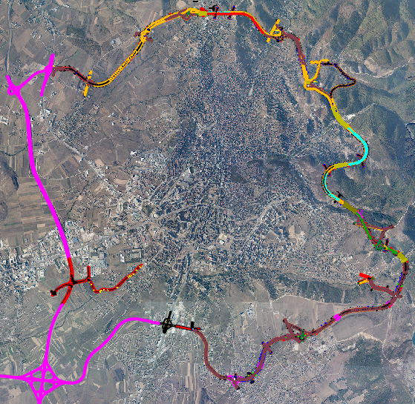  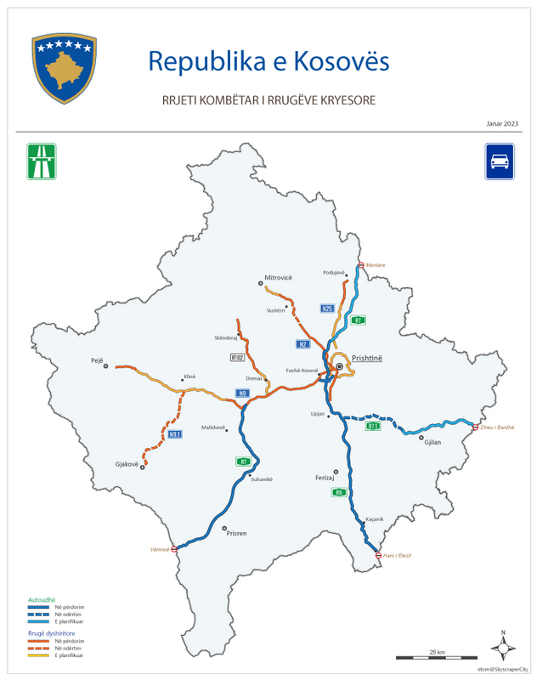
Total investment estimated:  - Preparatory activities (planning documentation, technical documentation, land acquisition etc.)  - Construction works  - Supervision | Total investment estimated: 386,050,000 EUR  Of which:  - Preparatory activities (Including expropriation): 120,000,000 EUR  - Construction works: 260,000,000 EUR  - Supervision of works: 6,050,000 EUR
Responsible or authorized person for contact: | Gezim Kastrati
Name – Position: | Gezim Kastrati, Advisor, Mayor’s Office
Email address - Telephone: | gezimkastrati@gmail.com  +38349468468
2. PROJECT DESCRIPTION
Purpose of the infrastructure project | The proposed project involves the construction of a new 19 km bypass encircling the capital city Prishtina. Its primary objective is to enhance the road infrastructure and services in the vicinity of the city, thereby facilitating the smooth flow of passengers and goods while reducing transportation costs.  The project aims to achieve three key goals:  i) Enhancing the city's integration with Pan-European corridors: The project will provide improved access and connections, allowing for better integration of Prishtina with Pan-European transportation networks.  ii) Addressing air pollution in the city center: By reducing congestion and diverting cargo traffic away from the city center, the project seeks to improve air quality and mitigate the issue of unhealthy air pollution concentrations, which currently exceed 150 μg PM2.5/m3.  iii) Enhancing road safety and standards: The project will contribute to improved road safety by relieving congestion and reducing the risk of accidents. Traffic accident research conducted in 2017 revealed that the rate of injuries in Prishtina is nearly three times higher than the EU average of 283 injured persons per 100 thousand inhabitants.  The project builds upon the existing Urban Transport Project undertaken in collaboration with the city. This initiative included technical support for the development of a Sustainable Urban Mobility Plan (SUMP), with the final report published in January 2019. The Inner Ring Road forms an integral part of the City's SUMP agenda.  The implementation of this project would discharge the inner city from traffic, especially from the number of vehicles that pass through the city in transit.
Results of the infrastructure project | The implementation of the project will directly impact the improvement of the road infrastructure and services surrounding the city, facilitating the smooth flow of passengers and goods while reducing transportation costs. Additionally, in the Southeast Europe region, this project makes a significant contribution to increasing the volume of transit traffic between the SEETO network and the rest of Europe. Furthermore, the project will yield the following benefits:  - Reduction of travel times: The project will result in shorter travel durations for commuters and transport of goods;  - Reduction of road infrastructure maintenance costs: With improved infrastructure, the project will help decrease the expenses associated with maintaining the roads;  - Cost efficiency in environmental protection, accidents, and congestion: The project aims to achieve cost-effective measures in mitigating environmental impacts, reducing accidents, and alleviating congestion compared to other competing roads.  - Fostering development of the Western Balkans: By enhancing connections, the project contributes to the development and progress of the Western Balkans region;  - Economic growth and social development: The improved road infrastructure stimulates economic growth and fosters social development in the area;  - Facilitating trade and economic links: The project plays a vital role in facilitating trade and strengthening economic ties with neighbouring countries and European Union member states;  - Providing safe and reliable trips: The project aims to enhance road safety and ensure reliable transportation for all road users;  - Improved road capacity: The project contributes to enhancing road capacity, allowing for smoother traffic flow and improved efficiency.  Overall, the realization of this project brings about multiple benefits that positively impact transportation, economic growth, and regional connectivity.
General description | Significant improvements have been made to Kosova's road network through the construction of essential motorways, namely R6, R7, and R7.1. These motorways establish vital connections between Kosova and its neighboring countries, including North Macedonia, Albania, and Serbia, respectively.  In addition to the motorways, the national road network features key routes, such as N2. Originating from the northern border with Serbia, N2 traverses through Prishtina, extending all the way to the southern border with North Macedonia. At its southern terminus, N2 provides a crucial link between Prishtina and the Pan-European Corridor X.  The beneficiary of the Project is the Municipality of Prishtina, capital city of Kosova with a population of 218,728 according to the latest registration in 2021. Prishtina is strategically located at the intersection of two vital international transportation corridors, namely Corridor VI and Corridor VII.  With a significant urban development in recent years and construction of new residential and commercial buildings the city has seen also an increase in infrastructure projects, including road improvements and public transportation initiatives. Following this, Prishtina has been a major driver of economic growth in Kosova. With expansion of various industries, including construction, services and trade, it has attracted foreign investments and hosted international companies.  The Prishtina Bypass project aims to address several key problems and deficiencies in the existing transportation system in Prishtina. Here are some common issues that the project intends to solve:  Congestion and Traffic Overload: Prishtina currently experiences high levels of traffic congestion, especially during peak hours. The existing road network is not able to efficiently handle the increasing number of vehicles, leading to delays, longer travel times, and frustration among commuters.  Inadequate Road Capacity: The existing road infrastructure in Prishtina does not have sufficient capacity to accommodate the growing population and the increasing number of vehicles. This results in bottlenecks, particularly in areas with heavy traffic flow, leading to reduced efficiency and mobility.  Lack of Connectivity: The current road network in Prishtina has gaps and limitations in terms of connectivity between different parts of the city. This lack of connectivity results in inefficient travel routes, longer distances, and increased travel times for both residents and commuters.  Safety Concerns: The existing road system has also safety deficiencies, including inadequate signage, poor lighting, and substandard road conditions. These factors contribute to an increased risk of accidents and pose a threat to the safety of road users.  The commencement date for work execution of this project is foreseen in the first quarter of 2024, with a minimum of 4 years’ duration.  The construction of a 19 km long road within the capital city of Prishtina, along with the integration of R7, R7.1, and R6, ultimately connecting with Corridor X (E-75), will significantly contribute to the enhancement of the network's capacity. This development will facilitate quicker integration into the Pan-European and Regional system, encompassing the Comprehensive Network of Southeast Europe (SEE). As a result, a substantial increase in the movement of people and goods is expected, further fostering economic and regional growth.

3. ELIGIBILITY

Coherence with valid EU policies and strategies | The Economic and Investment Plan for the Western Balkans announced in Brussels on October 6, 2020, underlines “the EU's commitment to prioritize projects and programs that extend the Trans-European Transport Network (TEN-T) core network and are of strategic interest to the region and the EU. It promotes further regional cooperation, integration, and connectivity between capitals in the region and the EU.  The Instrument for Pre-Accession Assistance (IPA III) for 2021-2027 recognizes that improving sustainable connectivity within the IPA III beneficiaries and between them and the European Union is crucial for economic growth and will bring clear benefits to the region's economies and citizens. The transport sector is identified as having strong potential to contribute to competitiveness and trade. IPA III emphasizes the importance of combining transport modes efficiently, including road, rail, maritime, and inland waterways, to achieve competitive, sustainable, and environmentally friendly transport solutions. It also focuses on transport safety and security, particularly in road transport, and passengers' rights in line with EU requirements and targets for reducing road fatalities and serious injuries. Additionally, IPA III supports the construction of new transport infrastructure, the upgrading of existing infrastructure, the establishment of intermodal connections, and the gradual shift from individual road transport to public or shared mobility.  The Treaty establishing the Transport Community, ratified on October 27, 2017, aims to create a Transport Community that focuses on road, rail, inland waterway, and maritime transport, as well as the development of the transport network between the European Union and the South East European Parties. This treaty reinforces the importance of regional cooperation and integration in the field of transportation between the EU and the Southeast European countries.  Overall, these various documents and initiatives demonstrate the commitment of Kosova, the EU, and the region to prioritize connectivity, infrastructure development, and sustainable transport in order to foster economic growth, enhance regional cooperation, and strengthen integration between the Western Balkans and the European Union.
Contribution to valid national development objectives | The project aligns with the Stabilisation and Association Agreement (SAA) between Kosova and the European Union, as outlined in Article 113 of the agreement. The SAA emphasizes cooperation in priority areas related to EU transport regulations, including restructuring and modernizing Kosova's transport systems, improving related infrastructures (including regional links identified by the South-East Europe Transport Observatory), enhancing the free movement of passengers and goods, achieving interoperable standards comparable to those in the EU, and aligning transport legislation with EU norms when circumstances permit. The cooperation aims to facilitate progressive mutual access to the EU and Kosovo transport markets, develop a compatible and interoperable transport system in Kosovo aligned with the EU, and enhance environmental protection in the transport sector.  The EU Country Report for Kosovo 2023 recommends the implementation of the CONNECTA report to improve the quality of the road network and related actions.  National Programme for European Integration 2023-2027 highlights the promotion of modern road and rail infrastructure to connect with the Pan-European corridors. The investment in road infrastructure is identified as one of the main priorities of the Kosova Government in its pursuit of European integration.  The Medium-Term Expenditure Framework 2022-2024, published in April 2021, emphasizes the continuation of investments in nationally and internationally significant road and railway infrastructure. It also emphasizes the construction of vital national infrastructure connecting different regions of Kosova to ensure economic growth.  The Economic Reform Programme 2024-2026 includes a reform measure (#13) focused on the further development and modernization of the transport sector.  The Program of the Municipality of Prishtina for the period 2021-2025 demonstrates the commitment of local leadership to the construction of the Prishtina Bypass.  Overall, these various policy documents and frameworks, including the SAA, the EU Country Report for Kosovo 2023 Report, the National Programme for European Integration, the Economic Reform Programme, and the Municipality of Prishtina's program, collectively emphasize the importance of modernizing and developing Kosova's transport infrastructure, connecting to Pan-European corridors, and prioritizing investments in the road sector as part of Kosova's European integration efforts.
Coherence with national Transport Sector Strategic framework | The Multimodal Transport Strategy 2030 sets forth the objective of establishing a sustainable and integrated transport system by enhancing various modes of transportation, including road, rail, and air. By prioritizing factors such as convenience, speed, cost, reliability, and predictability, the strategy aims to provide more efficient transport solutions for both people and goods. This comprehensive approach aims to alleviate congestion on roads and promote an environmentally friendly, safer, and cost-effective transportation sector. By optimizing the strengths and advantages of each mode of transport and integrating them effectively, the strategy seeks to create a seamless and interconnected transport network that meets the evolving needs of society.
- STRATEGIC RELEVANCE
Explain the features of the project in terms of:
Improving inter-modality | The implementation of the project will directly enhance the road infrastructure and services in and around the city, thereby facilitating the smooth movement of passengers and goods while reducing transportation expenses. Additionally, it will improve the efficiency and attractiveness of a single trip made with more than one transport mode (e.g. walking, taxi, bicycle and bus), with the aim of offering travelers a seamless journey.
Increasing international traffic (freight, persons) | The construction of a 19 km long bypass in the capital city of Prishtina, along with the connection of R7, R7.1, and R6 to Corridor X E-75, will play a pivotal role in enhancing network capacity. This development will lead to expedited integration into the Pan-European and Regional system, as well as the comprehensive network of the Southeast Europe (SEE) region. As a result, there is a justifiable expectation that both the movement of people and the transportation of goods will experience significant increases.
Being included in the latest Multi-annual plan (MAP) of SEETO | N/A
Providing connection to TEN-T corridors | Yes, the Prishtina Bypass is designed to provide a connection to the TEN-T (Trans-European Transport Network) corridors. The Prishtina Bypass, by linking to the TEN-T corridors, will enhance connectivity between Prishtina and the broader European transport network, contributing to the integration of Kosova's transport system with the Pan-European infrastructure.
Its contribution to Improvement of safety conditions | The proposed project entails the construction of a new 19 km road encircling the capital city of Prishtina. Its primary objective is to enhance road safety and standards by diverting cargo traffic away from the congested city center. By improving the road infrastructure and services in the vicinity of the city, the project aims to create safer conditions for both passengers and goods. The diversion of cargo traffic will reduce the risks associated with heavy vehicles flow through densely populated areas, thus minimizing the potential for accidents and improving overall road safety.
New, upgraded or rehabilitated infrastructure | A new 19 km stretch of greenfield infrastructure will be built, featuring a new alignment that will connect to the R6 corridor. This project involves the construction of entirely new infrastructure, allowing for the creation of an efficient and modern transportation route.
Meeting annual traffic demand growth | Currently, there is an annual traffic growth rate of 5%. Based on the findings of the feasibility study, the characteristics of the new road will be designed to accommodate this increasing traffic demand. The project takes into account the anticipated growth and ensures that the road's specifications and capacity align with the projected traffic volumes. By considering the future needs of transportation, the new road will be equipped to handle the rising traffic levels effectively and efficiently, providing a reliable and sustainable solution for the growing demands of the region.
Time reduction for journeys | The construction of the Prishtina Bypass will yield a substantial reduction in travel time within the city, with an estimated decrease of 10.06%. This means that commuters and travelers will experience significantly shorter journey durations when moving from one part of the city to another. Additionally, the new road will also contribute to reducing travel time for connections to the R6 and R7 corridors, further enhancing transportation efficiency and connectivity. The improved accessibility and reduced travel times offered by the Prishtina Bypass will benefit both local residents and those passing through the city, enhancing overall transportation convenience and facilitating smoother movement of people and goods.
Its effect on the reduction of CO₂ and noise emissions | The construction of the Prishtina Bypass is expected to have a positive effect on the reduction of CO2 and noise emissions.  By providing an alternative route for vehicles, the Prishtina Bypass will help optimize traffic flow within the city. This can lead to reduced congestion and traffic jams, resulting in smoother vehicle movement and lower idling times. As a result, fuel consumption and CO2 emissions from vehicles will be reduced.  The new road infrastructure can be designed with modern technologies and standards that prioritize energy efficiency. This includes features such as improved road surface materials, better traffic management systems, and optimized intersection design. These elements contribute to smoother traffic flow, reduced stop-and-go situations, and ultimately lower fuel consumption and emissions.  By diverting cargo traffic away from the city center, the Prishtina road helps alleviate congestion in urban areas. This reduction in traffic volume can lead to decreased vehicle emissions, including CO2 and noise. It also improves air quality and creates a more pleasant living environment for residents in the city center.  As part of the road construction project, noise barriers can be incorporated along certain sections of the Prishtina Bypass. These barriers help mitigate the noise generated by road traffic, protecting nearby residential areas and promoting a quieter living environment.  Overall, the Prishtina Bypass design and impact on traffic patterns have the potential to contribute to the reduction of CO2 emissions and noise pollution. These environmental benefits align with sustainability goals and promote a more eco-friendly and livable city.
Its contribution to overall economic growth | The Prishtina Bypass is expected to make a significant contribution to overall economic growth in the region.  Tourism and Hospitality: The Prishtina Bypass can improve accessibility to tourist destinations and cultural sites within and around Prishtina. This can boost tourism and hospitality sectors, attracting more visitors, generating revenue, and creating employment opportunities in the tourism industry.  Overall, the Prishtina Bypass’ positive impact on connectivity, trade facilitation, employment, real estate, and tourism can contribute to overall economic growth. It has the potential to stimulate various sectors of the economy, attract investments, and improve the quality of life for residents, ultimately fostering sustainable economic development in the region.
Its integration with other projects | The Prishtina Bypass project is seamlessly integrated with the existing R7, R7.1, and R6 routes, forming a vital bypass connection that effectively shortens the travel distance required to connect to Corridor X. This integration plays a pivotal role in enhancing the transportation infrastructure of the capital city and represents a substantial investment in the modernization of Kosova's road transport network.
The existence of alternatives | The Feasibility Study thoroughly examined all available alternatives and carefully evaluated their viability. After conducting a comprehensive Cost-Benefit Analysis (CBA) and reaching a consensus between the Government and Municipality, a decision was made to utilize the Prishtina ring road as a bypass to connect with national corridors. This selection was based on its optimal suitability and feasibility, considering factors such as traffic flow, infrastructure capacity, and economic considerations. The collaborative agreement between the Government and Municipality played a crucial role in ensuring the effectiveness and success of this decision, as it involved a shared understanding of the benefits and advantages that the Prishtina Bypass offers as a viable connection to national corridors.

Part Two
- MATURITY
Available studies and documents | Ready and approved | Being worked on | Not started yet
Conceptual idea | X
Pre-feasibility study | X
Conceptual design | X
Feasibility study + CBA | X
EIA study (if needed) | X
Valid spatial planning documents | X
Land property resolved |  | X
Preliminary design | X
Main design/detailed design |  |  | X
Tender documentation |  |  | X
Construction and other permits |  |  | X
Construction contract signed |  |  | X
- DETERMINATION OF SOURCE OF FUNDING
 | Yes | Justification | No
Does the project enhance connectivity? | X | Yes, the Prishtina Bypass has the potential to enhance connectivity in the region. As a bypass route, it provides an alternative and efficient connection to national corridors. By diverting traffic away from congested urban areas, the road can alleviate traffic congestion and improve transportation efficiency. This improved connectivity can benefit various stakeholders, including commuters, businesses, and logistics operations, by reducing travel times, enhancing accessibility to different parts of the city, and facilitating smoother movement of goods and services. Additionally, the road can contribute to regional integration by promoting easier access to neighboring areas and facilitating economic development by enhancing trade and commerce.
Does the project have cross-border impact or impact on other countries in the region? | x | The Prishtina Bypass is not just a local infrastructure project; it serves as a vital regional transit road that plays a significant role in connecting main country corridors. Its strategic position and connectivity have cross-border impacts that extend beyond national borders, fostering regional integration and facilitating transportation links with neighboring countries such as Albania, Serbia, and others. By serving as a crucial link between these nations, the road enhances regional connectivity, streamlines cross-border trade, and promotes economic cooperation. It creates a seamless and efficient transit route, facilitating the movement of goods, services, and people across borders, thereby fostering regional development and integration.
Can the project in any other way be earmarked as a regional project? | X | By focusing on improving the city's connectivity, the Project aims to facilitate smoother integration into the broader European transportation framework.  By investing in the enhancement of transport infrastructure, the project aims to reduce travel times, optimize transportation efficiency, and improve the city's connectivity to key Pan-European corridors. These corridors serve as vital links for the movement of goods, services, and people across the continent.  Through its implementation, the project strives to unlock new opportunities for the city, allowing it to become a more integral part of the European transport network. By strengthening the city's access to Pan-European corridors, the project supports regional integration, stimulates economic development, and promotes closer ties with neighboring countries.
- SPENDING SCHEDULE
 | 2021 | 2022 | 2023 | 2024 | 2025 | 2026 | 2027 | 2028 | 2029 | 2030
Costs (in mil. EUR) of which: |  | 1.05 | 60 | 91 | 61 | 61 | 61 | 51
Project preparation (TA) |  | 1.05 | 60 | 61 | 1 | 1 | 1 | 1
Investment |  |  |  | 30 | 60 | 60 | 60 | 50

- OTHER ASPECTS
Have IFIs or other donors already been consulted on the project? When? What was their judgement? | A donor consultation meeting took place on 10 May 2023, where IFIs and other donors were invited to participate in a general discussion on the projects in the Transport sector SPP prior to its validation and approval.
Existing EU or WBIF support (TA): amount, purpose | No.
Has the Ministry of Finance already been consulted on the project? Describe feedback. | Yes.
Does the project generate revenues from end users? | Possibly in the future.
Description of project team for implementation | PIU is existing for all project investments from grants and loan agreements.

