Project Identification Form (PIF): Transport Sector

Part One

- GENERAL INFORMATION

Project title: | General rehabilitation and modernization of the South/West Railway Line Klinë – Prizren; 58.831 km
Sector | Transport
Subsector* (see list on the last page) | Rail
Lead project Beneficiary/proponent: | Ministry of Environment, Spatial Planning and Infrastructure (MESPI); Ministry of Economy (ME)  Kosova Railways Infrastructure JSC – INFRAKOS
Institution that is the author of the project proposal | Kosova Railways Infrastructure JSC – INFRAKOS, MESPI
Location/Map | 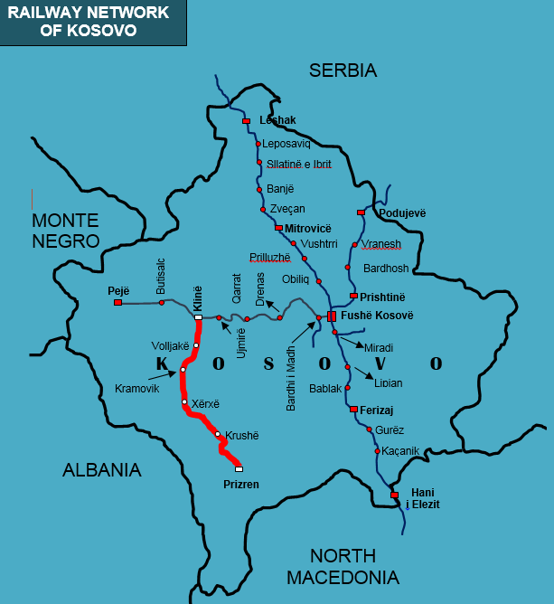
Total investment estimated:  - Preparatory activities (planning documentation, technical documentation, land acquisition etc.)  - Construction works  - Supervision | Total investment: 187,675,000.00 EUR  Of which:  - Preparatory activities: 3,000,000.00 EUR  - Construction works: 180,175,000.00 EUR  - Supervision: 4,500,000.00 EUR
Responsible or authorized person for contact: | Naser Krasniqi
Name – Position: | CEO of INFRAKOS JSC
Email address - Telephone: | naser.krasniqi@kosovorailway.com  Tel: +383 38 550 550 ext.505

- PROJECT DESCRIPTION
Purpose of the infrastructure project | The main objective of this project is to rehabilitate and modernize the railway line Klinë - Prizren in order to increase safety, speed, capacity, and have interoperable railway infrastructure based on EU standards through which will develop the railway market in Kosova and beyond.  This railway line is of high interest for Kosova, as well as social and environmental benefit. Through the implementation of this project Kosova businesses and industry will have potential growth and better connections with Albania, Serbia, North Macedonia and wider regional businesses through Railway Route 10 and connection with Port of Durrës. This project is of high social and economic interest given that connectivity, especially transport links, contribute to growth by enabling movement of goods, services, capital, people and information within Kosova and wider.  Through this project Kosova will save road infrastructure, develop intermodal and multi modal transport, and increase number of people with improved access to services.
Results of the infrastructure project | Developing this project INFRAKOS will achieve to realize needed general rehabilitation and modernization of this line in order to have interoperable railway infrastructure through which safe railway transport and railway market opening for domestic, regional and international train operators will be supported. The main stakeholders affected by this project are the state railway operator of Kosova (TRAINKOS) and all other train operators (local, regional and EU) who would like to use this infrastructure in the future.  General rehabilitation of South/West Railway Line (Klinë – Prizren) will result in:  - increased safety and speed conditions of this line;  - interoperable railway infrastructure as a linkage between neighboring countries and the wider region;  - better conditions for development of the passenger and freight transport;  - increased economic growth and social development;  - facilitated trade and economic links with neighboring countries and EU member states;  - improvement of transport capacities;  - development of multimodal and intermodal transport in Kosova and beyond.  Also, this project will establish railway traffic between Central Railway Node in Fushë Kosovë and South/West part of Kosova.
General description | The South/West Railway Line sustained significant damages during the period 1990-1999, and as a consequence this line is out of function and needs general rehabilitation. Therefore, in order to fulfil projected conditions of the line there is a need for general rehabilitation and modernization in order to achieve projected speed (80 km/h up to 120 km/h). The line includes 58.930 km long, single track, standard gauge (1435 mm) non-electrified rail line.  A feasibility study financed by WBIF and implemented by IPF Technical Assistance was undertaken during 2012/2013. The most beneficial option for South/West Railway Line upgrade in Kosova was proved to be general rehabilitation and electrification of the line. The next step towards implementation of this project is the preparation of the detailed design in the first phase, and general rehabilitation and modernization in the second phase of this line.  The South/West Railway Line (Klinë – Prizren) is very important for the future connection of Corridor X – Railway Route 10 and Corridor VIII.  This is a regional project connecting Kosova and a neighboring Country (Albania) in the future. It contributes to regional cohesion and will assist in the development of seamless connections for passengers and freight in the Western Balkans. Except for the connection for the South/West of Kosova, this will serve as the shortest direct railway connection of Sea Port of Durrës in Albania in the future.  In order to achieve EU standards and increase safety conditions, there is an immediate need for general rehabilitation and modernization of this line.

- ELIGIBILITY
Coherence with valid EU policies and strategies | The South/West Railway Line (Klinë – Prizren) is a regional project because this will serve as the shortest direct railway connection of Sea Port of Durrës in Albania in the future.  An Economic and Investment Plan for the Western Balkans promotes “multimodal transport solutions and modal shift, through targeted policies, including investment in inland waterways, will be needed. The infrastructure connections between sea/inland waterways ports and the rail network are currently weak or non-existent and reducing transport related pollution.” Thus, the Plan foresees that “action will be taken to speed up construction of new transport infrastructure and the upgrading of existing infrastructure, with the objective of bringing the core transport network up to EU standards.”  According to the European Green Deal, Brussels 11.12.2019, states that “a substantial part of the 75 per cent of inland freight carried today by road, needs to be shifted to rail and inland waterways.”  Guidelines for the Implementation of the Green Agenda, Brussels 6.10.2020, for the Western Balkans considers the revitalisation of rail network as top priority and promotion of multimodal transport solutions and modal shift, through targeted policies, including investment in inland waterways, is needed. Also, it is stated that “implementation of EU technical standards in all transport modes, in particular the European Railway Traffic Management System” should be ensured.  A credible enlargement perspective for and enhanced EU engagement with the Western Balkans, Strasbourg, 6.2.2018, states that “it is a political priority to connect infrastructure also between the EU and the Western Balkans and to accelerate the development of interconnected trans-European networks in the fields of transport, energy and digital services.”  Sustainable and Smart Mobility Strategy: “Mobility in Europe should be based on an efficient and interconnected multimodal transport system, for both passengers and freight, enhanced by an affordable high-speed rail network, by abundant recharging and refueling infrastructure for zero-emission vehicles and supply of renewable and low-carbon fuels, by cleaner and more active mobility in greener cities that contribute to the good health and wellbeing of their citizens.” The same strategy foresees that by 2030 high-speed rail traffic will double, and by 2050 rail freight traffic will double whereas high speed rail traffic will triple. The same strategy foresees through “FLAGSHIP 4 - GREENING FREIGHT TRANSPORT - Ensuring road/rail connections to TEN-T ports/airports, freight terminals, and removing bottlenecks for intermodal transport, by 2025.”  Strategy for Sustainable and Smart Mobility in the Western Balkans, July 2021 states that “Interventions are required to increase railway capacity and enable more competitive rail services”. Also, the strategy says that:  - By 2030, rail freight traffic to increase by 20 percent. This to double by 2050;  - By 2035, rail and waterborne-based intermodal transport to compete on equal footing with road-only transport in the Western Balkans.  The EU’s Fourth Railway Package (2013) foresees improving the interoperability and safety of national networks and developing rail transport infrastructure.  One of the objectives of EBRD stated in Transport Sector Strategy (2019-2024), October 2019, is the “investment in rehabilitation and expansion of national, regional and sub-urban rail infrastructure and signaling, to improve access to markets and services, and create linkages to key transport networks and corridors, including TEN-T, WBCN, CAREC, TRACECA and BRI in the economies where the Bank invests.”  ECONOMIC REFORM PROGRAMME OF KOSOVO (2021-2023), 2021 foresees that further connectivity with neighboring countries would strengthen the country’s integration into the regional market.
Contribution to valid national development objectives? | Improving connectivity within our region as well as with the EU is a key factor for growth and jobs in the WB. Meanwhile, developing this project, INFRAKOS and the Ministry of Environment, Spatial Planning and Infrastructure will fulfil part of their development strategies. Modernization of the rail infrastructure is considered as one of the governmental objectives of the National Programme for European Integration 2023-2027.  The Government intends through development banks to finance the rehabilitation of the East-West railway line of Kosova, which enables a rail link with Albania and Montenegro; respectively a connection to the sea ports on the Adriatic will be created.  The project is in line with the Stabilisation and Association Agreement (SAA), between Kosova and the European Union as stated in Article 113 of this agreement:  “Cooperation between the Parties shall focus on priority areas related to the EU acquis in the field of transport. Cooperation may notably aim at restructuring and modernising Kosova’s transport systems and improving related infrastructures (including regional links as identified by the South-East Europe Transport Observatory), improving the free movement of passengers and goods, achieving standards interoperable with and comparable to those prevailing in the EU and aligning transport legislation to that of the EU, should objective circumstances so permit. Cooperation shall aim to contribute to progressive mutual access to the EU and Kosova transport markets and facilities as provided for in this Agreement, developing a transport system in Kosova compatible, interoperable and linked with the EU system, and improving environmental protection in the field of transport.”  In the Program of the Government of the Republic of Kosova 2021 – 2025, the government stresses its commitment to create an integrated system for road, rail and air transport, for the purpose of economic development, and to modernise and develop the railway infrastructure, in order to provide more sustainable services.  EU Country Report for Kosovo (2023) states: “Kosovo should implement the pending connectivity projects and strengthen institutional and administrative capacities for the implementation of strategic infrastructure projects.”  The Government intends through development banks to finance the rehabilitation of the western railway line, which allows cheaper transportation of people and goods.
Coherence with national Transport Sector Strategic framework | Multimodal Transport Strategy 2030 aims to bring a sustainable and integrated transport system by strengthening different modes (road, rail and air), such as convenience, speed, cost, reliability, predictability, etc., and in combination, can offer more efficient transport solutions for people and goods which will help ease the pressure in our congested roads, and make the whole sector more environmentally friendly, safer, and cost-effective. Also it is stated that “EU’s transport policy is naturally aligned with the global trends presented above. It can be emphasized though that there is a special attention being made towards the uptake of zero-emission vehicles, development of rail transport and the reinforcement of a single market which is based on the user-pays principle.”

- STRATEGIC RELEVANCE
Explain the features of the project in terms of:
Improving inter-modality | By implementing the general rehabilitation and modernization of this line, Kosova will improve and develop highest level intermodal transport on a local, regional and international level.
Increasing international traffic (freight, persons) | Through this project Kosova will increase passenger and freight transport and at the same time will improve conditions for transport.  According to Feasibility Study, after rail network rehabilitation, it is to expect substantial improvements in traffic volumes along the lines for both passengers and freight. In year 2040, the passenger traffic volume would reach 413 thousand passengers on Klinë-Prizren line. At the same time, the freight traffic volume would reach 91.2 million tons on Klinë-Prizren line.
Being included in the latest Multi-annual plan (MAP) of SEETO | No, this project is not included in the SEETO MAP 2018.  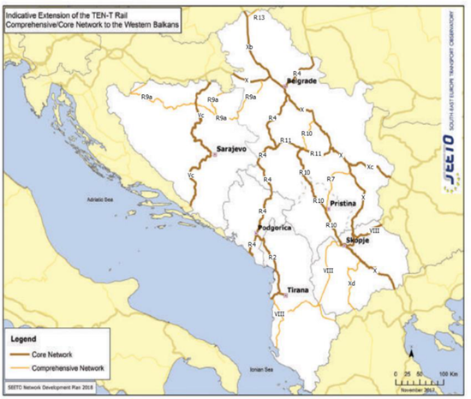
Providing connection to TEN-T corridors | The line will serve as a future connection line between Corridor VIII and TEN-T Corridor X.
Its contribution to Improvement of safety conditions | Rehabilitation of this line will be done in accordance with the contemporary railway safety standards. Having in mind the current condition of the respective railway line, this project would have significant impact on the safety aspect.
New, upgraded or rehabilitated infrastructure | General rehabilitation and modernization of the South/West Railway Line.
Meeting annual traffic demand growth. | The project meets the requested criteria for transport growth.
Time reduction for journeys | The Network Development Plan of Infrakos (2018) with rehabilitation and modernization of this line, foresees that the time reduction for journeys in this line will be about 40 min.
Its effect on the reduction of CO₂ and noise emissions | Realizing this project will lead to the predominant part of road freight transport being shifted to railways which would have significant impact in respect to the reduction of CO₂ and noise emission.  This project has sustainability in relation to environmental aspects, because it is known that trains have very low emission of C02 comparing with road vehicles. In this way we will have clean environmental ambient along the railway line. This project will consider environmental implications so that any negative impacts on the environment will be either avoided or mitigated during the life of the project.
Its contribution to overall economic growth | This railway line, there is no direct link with the international traffic, but it considers as a feeder of Railway Route 10. In the future the project would facilitate significant inter-regional economic growth since it’s connecting Kosova and a neighboring country (Albania) and it contributes to regional cohesion and assist in the development of seamless connections for passengers and freight in the Western Balkans.  Enhancing connectivity within the Western Balkans represents a strategic interest for both sides. Increasing transport connections will allow for increased competitiveness, economic growth and security of supply, and is at the same time an important prerequisite for economic integration within the Western Balkans.  The Western Balkans are surrounded geographically by EU Member States and it is a political priority to connect infrastructure also between the EU and the Western Balkans and to accelerate the development of interconnected trans-European networks in transport.
Its integration with other projects | This project is in connection with the investments on Railway Route 10 in Kosova as well as with investments in railway infrastructure in Albania.
The existence of alternatives | In terms of alignment, there was no need for alternative analyses having in mind that the project is related to rehabilitation of the existing line. However, alternative options were explored when it comes to telecommunication, signaling and electrification options.

Part Two

- MATURITY

Available studies and documents | Ready and approved | Being worked on | Not started yet
Conceptual idea | X
Pre-feasibility study | X
Conceptual design | N/A
Feasibility study + CBA | X
EIA study (if needed) | X
Valid spatial planning documents | X
Land property resolved | X
Preliminary design |  |  | X
Main design/detailed design |  |  | X
Tender documentation |  |  | X
Construction and other permits |  |  | X
Construction contract signed |  |  | X

- DETERMINATION OF SOURCE OF FUNDING

 | Yes | Justification | No
Does the project enhance connectivity? | X | The realization of the project will have direct impact on the improvement of the railway connection within Kosova, with regional countries and Integrated EU Network.
Does the project have cross-border impact or impact on other countries in the region? | X | This railway line would have cross-border impact with Albania and also will have impact on other neighboring countries.
Can the project in any other way be earmarked as a regional project? | X | Taking into consideration the SEETO Comprehensive Railway Network, linkage to TEN-T, and future connection with Albania, this project can be considered as a regional project too.
- SPENDING SCHEDULE
 | 2015-2020 | 2021 | 2022 | 2023 | 2024 | 2025 | 2026 | 2027 | 2028 | 2029 | 2030
Costs (in million EUR) of which: |  |  |  |  | 1.50 | 1.50 | 61.50 | 61.50 | 61.675
Project preparation (TA) |  |  |  |  | 1.50 | 1.50 | 1.50 | 1.50 | 1.50
Investment |  |  |  |  |  |  | 60.00 | 60.00 | 60.175

- OTHER ASPECTS
Have IFIs or other donors already been consulted on the project? When? What was their judgement? | A donor consultation meeting took place on 10 May 2023, where IFIs and other donors were invited to participate in a general discussion on the projects in the Transport sector SPP prior to its validation and approval.
Existing EU or WBIF support (TA): amount, purpose | No.
Has the Ministry of Finance already been consulted on the project? Describe feedback. | The Ministry of Finance, Labor and Transfers is informed concerning this project and it will support it.
Does the project generate revenues from end users? | This project is as a precondition for future developments and will generate revenues from train operators.
Description of project team for implementation | INFRAKOS will establish a PIU for this project.

