Project Identification Form (PIF): Transport Sector
Part One

- GENERAL INFORMATION

Project title: | Digitalization of sustainable, safe, smart and environmentally friendly transport systems and Implementation of ITS on TEN-T Core/Comprehensive Network in Kosova
Sector | Transport
Subsector* (see list on the last page) | Road
Lead project Beneficiary/proponent: | Ministry of Environment, Spatial Planning and Infrastructure (MESPI)
Institution that is the author of the project proposal | MESPI
Location/Map | 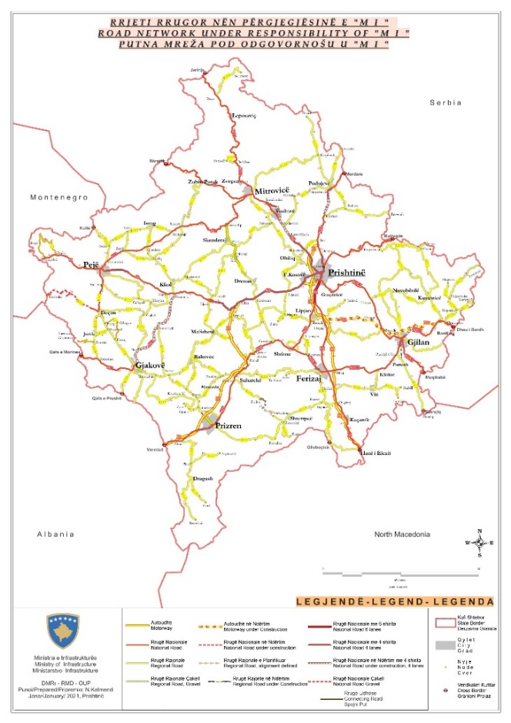
Total investment estimated:  - Preparatory activities (planning documentation, technical documentation, land acquisition etc.)  - Construction works  - Supervision | Total investment: 30,000,000.00 EUR  Of which:  - Preparatory activities: 4,000,000.00 EUR  - Construction works: 24,000,000.00 EUR  - Supervision of works: 2,000,000.00 EUR
Responsible or authorized person for contact: | Naim Kelmendi  Nezir Gashi  Fejzulla Mustafa
Name – Position: | Department of Road Infrastructure  Department for Road management  Department of Road Safety Coordination Council
Email address - Telephone: | naim.kelmendi@rks-gov.net; +383 (44) 203 053  nezir.gashi@rks-gov.net; +383 (44) 413 264  fejzullah.mustafa@rks-gov.net; +383 (44) 249 650

- PROJECT DESCRIPTION

Purpose of the infrastructure project | The purpose of this project is to initially improve road safety conditions and increase the capacity of the database by digitizing it using software systems based on CADAS-Protocol.  In addition, another purpose of the project will be to include the deployment of ITS which improves transportation safety and mobility and enhances productivity through the use of advanced communications technologies. When integrated into the transportation system’s infrastructure and within vehicles themselves, these technologies relieve congestion, improve safety and enhance productivity. This includes devices such as vehicle detection systems, lane control signals, ramp signals, variable message signs, CCTV cameras, incident detection, emergency telephones, cabling and ducting.
Results of the infrastructure project | The project will result in improving and minimizing accidents by checking and controlling the reasons of the accidents and taking all necessary measures to mitigate the source of the accident by minimizing or avoiding their cause.  The benefits of applying Intelligent Transportation Systems: Increase of street throughput; increase of road traffic safety (traffic accident reduction); improvement of traveling comfort and traffic conditions for drivers, mass transit passengers and pedestrians. So, the idea is to digitalize infrastructure and services on transport field.
General description | Kosova has a database of traffic accidents, but it is obsolete and not sufficient to investigate the main factors / causes of accidents. Establishment of a database of road accident data is important for road safety assessments and will directly affect and increase the safety of the existing and future road network.  Reducing the number of road fatalities requires continued engagement in the analysis of the database on road accidents. With the establishment of a modern and electronic database it would be easier to investigate the major accident factors. To continue reducing the number of road deaths and serious injuries, more data needs to be put into the database through a software (electronic registry).  The priority in setting up the ITS will be the motorways of Kosova, then the national roads expanded to 2+2 and 3+3 lanes, then the other national roads that are part of the core and comprehensive network.  The core and comprehensive road network in Kosovo has a length of 349 km, of which: motorway 138 km, national road with 2+2 lanes 43 km, national road with 2 lanes 148 km and national road in the process of widening 20 km. There is also a road segment with a length of 8km, 3+3 lanes which is not part of the core and comprehensive network, but which is very important with a very high level of traffic  With the support of the EU, the ITS Deployment Strategy is currently being drafted (through CONNECTA) which will be concluded this year. The Ministry has also requested technical assistance for the drafting of the feasibility study for ITS.  Activities planned for project implementation:  - Development of application for accident registration;  - Traffic Police use of digital maps;  - Use of digital devices (smart phones, tablets, etc.) by the Traffic Police; for marking tickets, reports of traffic accidents, printing them and linking to the SIPK / KP database;  - Continued use of digital equipment;  - Training of traffic police and other road safety actors on the use of digital equipment;  - Investigation of major accident factors;  - Analysis of all safety factors such as Road, Vehicle and Human beings (driver);  - Establishment of a prioritized list of road sections of increased risk (black spots) based on the above analysis.  After the completion of the national strategy and the Feasibility Study mentioned above, the conditions for the implementation of ITS in the core and comprehensive network will be created.

- ELIGIBILITY

Coherence with valid EU policies and strategies | The Instrument for Pre-Accession Assistance (IPA III) 2021-2027, states that IPA III will devote attention to transport safety and security, especially in road transport, and passengers’ rights in accordance with the EU requirements and targets to reduce road fatalities and serious injuries. Also, IPA III will support the construction of new transport infrastructure and the upgrading of existing infrastructure, with the objective of bringing the core transport network up to EU standards. It will also support intermodal connections and the gradual shift from individual road transport to public or shared mobility.  The digitalization component affects road safety, and is in coherence with the EU Road Safety Policy Framework 2021-2030 – Next Steps towards “Vision Zero”  ITS deployment is part of Sustainable and Smart Mobility Strategy, Brussels, 9.12.2020. Implementation of ITS will allow the implementation of EU Directive 2010/40/EU - Framework for the deployment of Intelligent Transport Systems in the field of road transport and for interfaces with other transport modes. The Green Agenda for the Western Balkans, Brussels, 6.10.2020, states that “There should be a focus on the deployment of Intelligent Transport System solutions (ITS) aimed at making transport operations more efficient and reducing CO2 emissions. Wide availability and use of data technologies in public transport systems has the potential to make them smarter, less polluting and customer friendly.”  Transport Community - STRATEGY FOR SUSTAINABLE AND SMART MOBILITY IN THE WESTERN BALKANS, July 2021, states that “Passengers should be able to travel without disruption across the region using sustainable mobility choices and different modes of transport. Businesses and logistics operators should experience fewer delays caused by excessive bureaucracy and paper trails. This increased multimodality should be led through digitalization and automation, supported by innovation. To achieve seamless travel, which is sustainable, the region should focus on: a) multimodal passenger ticketing, b) digitalized freight transport, c) intelligent transport deployment solutions for all modes, d) digital data exchange at borders and e) innovation.”  Currently, travelers are mostly unable to plan and book their trips online. From a passenger’s perspective, each transport mode currently still operates as a mostly isolated system. Currently, there is no digital connection or interface between international passenger transport and urban transportation through systems such as Mobility as a Service. The ITS Directive and the delegated regulation on multimodal travel information services regulates this area. Considering the inclusion of the revised EU legislation into the Transport Community Treaty Annex I and its consequent transposition by the Ministries in charge of Transport would be the first step towards achieving multimodal ticketing in the Western Balkans region.”  Sustainable and Smart Mobility Strategy, Brussels, 9.12.2020, states that “The Commission will explore options to further support safe, smart and sustainable road transport operations under an existing agency or another body. This body could support the deployment and management of ITS and sustainable connected and automated mobility across Europe.”  Road safety Action Plan, Transport Community, October 2020, promotes safety management, safer infrastructure, and protection of road users. Its actions strive to support the “zero deaths” objective, and to encourage regional best practice examples. Transport Community’s aim is to ensure that transport systems, no matter how they are configured, are safe, sustainable, and equitable.
Contribution to valid national development objectives | The Operational Strategic Plan of the Kosova Government 2022-2025 mentions the Placement of Intelligent Transportation System (ITS).  EU Country Report for Kosovo 2023 states that “Kosovo should also implement the report recommendations of Technical Assistance to Connectivity project in the Western Balkans - CONNECTA - to improve the quality of the road network and implement actions as set out in the road safety Transport Community Treaty regional action plan.”
Coherence with national Transport Sector Strategic framework | Multimodal Transport Strategy 2030, states: “Digitalization in road transport takes many forms. Directive 2010/40/EU covers many intelligent transport systems (ITS) that need to be implemented in Kosovo as well. In order to do that, an ITS program shall be adopted. The first priorities in this field will be the implementation of road related ITS systems (variable road signs, road cameras, road weather, traffic counting etc.) Besides actions listed in the directive, a concept shall be drawn for the establishment of a nation-wide electronic ticketing system in Kosovo, which will be part of the public transport development program.  Digitalization of freight transport and logistics is encouraged through Regulation (EU) 2020/1056 on electronic freight transport information to reduce administrative costs, improve enforcement capabilities of competent authorities, and enhance the efficiency and sustainability of all transport modes.” Also the aims of this strategy is to bring a sustainable and integrated transport system by strengthening different modes (road, rail and air), such as convenience, speed, cost, reliability, predictability, etc., and in combination, can offer more efficient transport solutions for people and goods which will help ease the pressure in our congested roads, and make the whole sector more environmentally friendly, safer, and cost-effective.

- STRATEGIC RELEVANCE

Explain the features of the project in terms of:
Improving inter-modality | Implementation of ITS in the country will promote intermodality, especially through the development of intermodal interfaces.
Increasing international traffic (freight, persons) | The development of a safer road network and the ITS in parallel with the regional component, will lead in increased traffic of both freight and persons.
Being included in the latest Multi-annual plan (MAP) of SEETO | Yes, the ITS deployment will take place along the SEETO core and comprehensive network.
Providing connection to TEN-T corridors | N/A.
Its contribution to Improvement of safety conditions | Yes – the project is directly linked in the improvement of the safety conditions.
New, upgraded or rehabilitated infrastructure | The project will give information and gather data where the upgrade of route section shall be done, while the development of ITS will lead to the upgrade of the transport network.
Meeting annual traffic demand growth | The project contributes to meet requested criteria for transport growth.
Time reduction for journeys | Yes – Implementation of ITS along the main transport corridors will contribute to enhanced traffic operation that will reduce journey times.
Its effect on the reduction of CO₂ and noise emissions | ITS provides society-wide benefits, which include reducing accidents, overall levels of congestion, and emissions.
Its contribution to overall economic growth | Through the reduction of the time duration of journeys, VOC and traffic accidents, the project will contribute to the overall economic growth.
Its integration with other projects | Both the Road Safety and the ITS components of the project will be integrated with all developments and projects undertaken in Kosova.
The existence of alternatives | N/A

Part Two

- MATURITY

Available studies and documents | Ready and approved | Being worked on | Not started yet
Conceptual idea | X
Pre-feasibility study |  | X
Conceptual design |  |  | X
Feasibility study + CBA |  |  | X
EIA study (if needed) |  |  | X
Valid spatial planning documents |  |  | X
Land property resolved |  |  | X
Preliminary design |  |  | X
Main design/detailed design |  |  | X
Tender documentation |  |  | X
Construction and other permits |  |  | X
Construction contract signed |  |  | X

- DETERMINATION OF SOURCE OF FUNDING

 | Yes | Justification | No
Does the project enhance connectivity? | X | The ITS project will be developed mainly in the road segments that are part of the core and comprehensive network and will enhance connectivity through a coherent and homogeneous regional ITS component.
Does the project have cross-border impact or impact on other countries in the region? | X | Both ITS and Road Safety form major components of the regional development of a sustainable transport network.
Can the project in any other way be earmarked as a regional project? | X | The project may have a regional impact as accident data should be shared and / or other sites informed of potentially higher accident risk routes.  All the countries of the region are in different stage of deployment of ITS.
- SPENDING SCHEDULE

 | 2015-2020 | 2021 | 2022 | 2023 | 2024 | 2025 | 2026 | 2027 | 2028 | 2029 | 2030
Costs (in mil. EUR) of which: |  |  |  |  | 4 | 13 | 13
Project preparation (TA) |  |  |  |  | 4 | 1 | 1
Investment |  |  |  |  |  | 12 | 12

- OTHER ASPECTS

Have IFIs or other donors already been consulted on the project? When? What was their judgement? | A donor consultation meeting took place on 10 May 2023, where IFIs and other donors were invited to participate in a general discussion on the projects in the Transport sector SPP prior to its validation and approval.
Existing EU or WBIF support (TA): amount, purpose | - CONNECTA-TRA-CRM-REG-01: Preparation of Road Safety Inspection and Audit Plans for the Core/Comprehensive Road Network in Western Balkans and Pilots  - CONNECTA-TRA-CRM-REG-03: Strategic Framework for implementation of ITS on TEN-T Core/Comprehensive Network on the WB6  - CONNECTA-TRA-CRM-REG-ITS-08: Technical Assistance for preparation of national ITS strategy for Bosnia and Herzegovina, Kosovo (all modes), Albania (railway and maritime) and Montenegro (railway) and deployment of road traffic management centers in Bosnia Herzegovina and Kosovo
Has the Ministry of Finance already been consulted on the project? Describe feedback. | No.
Does the project generate revenues from end users? | No.
Description of project team for implementation | A dedicated PIU will be provided for this project.

DIRECTIVE 2010/40/EU OF THE EUROPEAN PARLIAMENT AND OF THE COUNCIL of 7 July 2010 on the framework for the deployment of Intelligent Transport Systems in the field of road transport and for interfaces with other modes of transport. https://eur-lex.europa.eu/legal-content/EN/TXT/PDF/?uri=CELEX:32010L0040&rid=9

