Project Identification Form (PIF): Transport Sector

Part One

- GENERAL INFORMATION

Project title: | Construction of the Dry Port Prishtina (Inland Port / Cargo Distribution Hub)
Sector | Transport
Subsector* (see list on the last page) | Rail, Road
Lead project Beneficiary/proponent: | Ministry of Environment, Spatial Planning and Infrastructure (MESPI); Ministry of Economy (ME)  Kosova Railways Infrastructure JSC – INFRAKOS
Institution that is the author of the project proposal | MESPI, Kosova Railways Infrastructure JSC – INFRAKOS
Location/Map | The Dry port is located in Fushë Kosova, city near Prishtina. The location of the Dry Port Prishtina is presented in the following map:  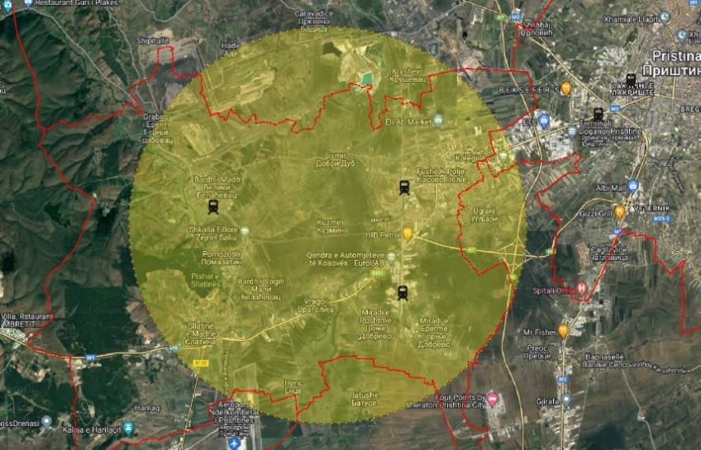
Total investment estimated:  - Preparatory activities (planning documentation, technical documentation, land acquisition etc.)  - Construction works  - Supervision | Total investment: 30,000,000 EUR  Of which:  - Preparatory activities: 2,000,000 EUR  - Construction works: 26,000, 000 EUR  - Supervision: 2,000,000 EUR
Responsible or authorized person for contact: | Naser Krasniqi
Name – Position: | CEO of Kosova Railways Infrastructure JSC - INFRAKOS
Email address - Telephone: | naser.krasniqi@kosovorailway.com  Tel: +383 38 550 550 ext.505

- PROJECT DESCRIPTION

Purpose of the infrastructure project | The overall objective of the project is to support transport infrastructure development as well as reform processes in the transport sector in Kosova and the region in line with the relevant EU Directives and Regulations. The project will enable better multimodality, better interconnections with other transport modes and environmentally friendly transport solutions which will combine transport modes by road and rail.  The main objective of Dry Port Prishtina is the connection of Prishtina with port of Durrës and main centres in Albania. The Dry Port will integrate the Port of Durrës and rail infrastructure between Albania and Kosova realizing a Gateway to the Western Balkans in relation with the development of distribution centers and logistics in the region.  By implementing this project, INFRAKOS and the Ministry of Environment, Spatial Planning and Infrastructure will fulfil part of their development strategies.  The project aims to improve connectivity in the region along core network corridors of the Trans-European Transport network. It could provide multi-modal link between Western Balkans countries through core railway network (Rail Route 10) and existing railway and road lines. The proximity to the existing terminal in Miradi and airport of Prishtina gives special importance to the project.  The Dry Port Prishtina will serve all modes of transport as a multimodal station where all cargo will be collected and then distributed. Also, it will increase the quality of multimodal transport services, improve freight efficiencies and capacities, develop and integrate the freight transport and protect environment from pollution.
Results of the infrastructure project | By constructing the new dry port, the opening of railway domestic, regional and international freight transport will be promoted.  The Dry Port Prishtina, as an extension of Port of Durrës, will enable the connection of Prishtina with Port of Durrës.  Implementation of this project will contribute to increasing capacity, safety and developing the railway market in Kosova and beyond. Also, the implementation will increase economic growth and social development, facilitate trade and economic links with neighboring countries and EU member states, and develop multimodal and intermodal transport in Kosova and beyond.  The port will boost the development of a modern combined freight transport by creating a partnership relationship between railway and road transport.
General description | This project is with high importance for the future development of intermodal transport of Kosova and wider region, taking into consideration that most inland freight in Kosova is transported by road and there is only one partly-developed intermodal railway terminal. Rail freight accounts for about 23.03 million tons-km or 550360 tons, and number of passengers was 121,060 in 2019.  The project includes construction of a Dry Port in Prishtina, which is an extension of Port of Durrës – Porto Romano. Port of Durrës is the largest seaport in Albania and located in the city of Durrës. The geographical locations of these ports are presented below:  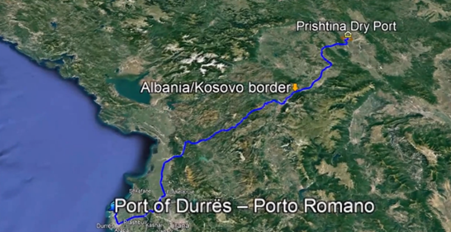  The Dry Port Prishtina will be located in Fushë Kosova city, the area near railway station, as presented in the below pictures.  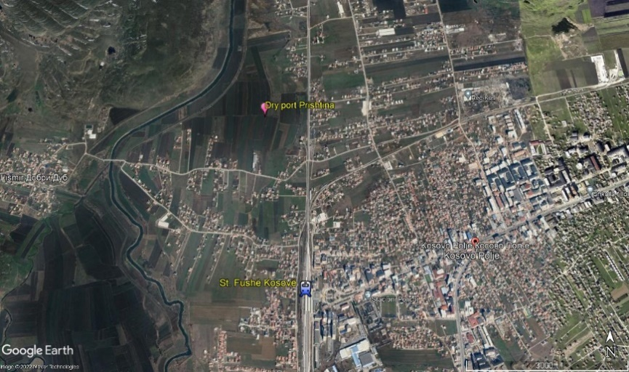  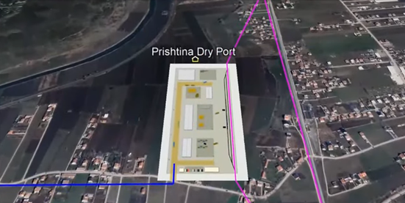  The new dry port will be located near industrial area, existing terminal in Miradi and airport Prishtina, and will be able to be connected to existing railway lines (Rail Route 10) and roads (R6 and R7 highways).  Rail Route 10 branches from Lapovo (Serbia) between Belgrade and Nis (Corridor X connects to Belgrade via Lapovo) and forms an alternative route to Skopje: Belgrade – Lapovo - Kraljevo-Fushë Kosova - Skopje.  The dry port will include construction of access roads and access railways, premises for storage and maneuvering, customs authority, logistics center, and an administrative building with parking facilities for freight vehicles. It will enable loading and/or the unloading of goods onto/from freight trains, and the integration of rail freight services with road, maritime, and air services.

- ELIGIBILITY
Coherence with valid EU policies and strategies | The project is in line with the Stabilisation and Association Agreement (SAA), between Kosova and the European Union as stated in Article 113 of this agreement:  “Cooperation between the Parties shall focus on priority areas related to the EU acquis in the field of transport. Cooperation may notably aim at restructuring and modernizing Kosova’s transport systems and improving related infrastructures (including regional links as identified by the South-East Europe Transport Observatory), improving the free movement of passengers and goods, achieving standards interoperable with and comparable to those prevailing in the EU and aligning transport legislation to that of the EU, should objective circumstances so permit. Cooperation shall aim to contribute to progressive mutual access to the EU and Kosova transport markets and facilities as provided for in this Agreement, developing a transport system in Kosova compatible, interoperable and linked with the EU system, and improving environmental protection in the field of transport.”  ‘Guidelines for the Implementation of the Green Agenda for the Western Balkans’, Brussels, 6.10.2020 states that: “The promotion of multimodal transport solutions and modal shift, through targeted policies, including investment in inland waterways, will be needed. The infrastructure connections between sea/inland waterways ports and the rail network are currently weak or non-existent.”  According to the European Green Deal, 2019, a substantial part of the 75 per cent of inland freight carried today by road needs to be shifted to rail and inland waterways.  Strategy for Sustainable and Smart Mobility in the Western Balkans, July 2021 in FLAGSHIP 4 notes that in the Western Balkans region, multimodal transport is in an early stage of development, and it is a crucial segment for the expected shift to rail. Also, it states that by 2030, rail freight traffic to increase by 20 percent and double by 2050.  Regulation (EU) No. 913/2010 of 9 November 2010 concerning a European rail network for competitive freight requires to promote intermodality between rail and other transport modes by integrating terminals into the corridor management process. According to the regulation when selecting further freight corridors, the existence of good interconnections with other modes of transport, in particular due to an adequate network of terminals, including in maritime and inland ports should be taken into account. Also, it is stated that the development of intermodal freight terminals should also be considered necessary to support the establishment of rail freight corridors in the Union and the operation of railway infrastructure and the terminals along freight corridor need to be coordinated.  Union guidelines for the development of the trans-European transport network, 2021 states that “The upgrade of the infrastructure for combined railway transport and of terminals is an important element to ensure that intermodal transport is primarily done by rail, inland waterways or short-sea shipping and that any initial and/or final legs carried out by road are as short as possible.”
Contribution to valid national development objectives? | Economic Reform Programme 2024-2026 foresees that further connectivity with neighboring countries would strengthen the country’s integration into the regional market.  National Programme for European Integration 2023-2027 promotes modern and better regional railway infrastructure, in order to connect to the Pan-European corridors.  EU Country Report for Kosovo (2023) states: “Kosovo should implement the pending connectivity projects and strengthen institutional and administrative capacities for the implementation of strategic infrastructure projects.”
Coherence with national Transport Sector Strategic framework | According to the Multi-Modal Transport Strategy 2030, access to terminals and service facilities should be enabled to all undertaking, private and state.”

- STRATEGIC RELEVANCE

Explain the features of the project in terms of:
Improving inter-modality | Construction of an intermodal Dry Port in Prishtina promotes developments of state-of-the-art combined transport by increasing the share of railway transport and creating a partnership with the road transport.  Though the construction of this port, Kosova will improve and develop highest level intermodal transport in local, regional and international level, because it is so close to the Freight Terminal in Miradi, Passenger Station in Fushë Kosova and Airport of Prishtina “Adem Jashari.”
Increasing international traffic (freight, persons) | Implementing this project in Kosova will increase freight transport and will improve conditions for transport. By 2050, it is expected that up to 100,000 containers to be handled in Dry Port Prishtina.
Being included in the latest Multi-annual plan (MAP) of SEETO | N/A
Providing connection to TEN-T corridors | The project aims to improve connectivity in the region along core network corridors of the Trans-European Transport network.  The dry port is an extension of Port of Durrës, which will be a very important Gateway to the Western Balkans in relation with development of distribution centers and logistics in the region.  The port will have direct access to core Rail Route 10 which branches from Lapovo (Serbia) between Belgrade and Nis (Corridor X connects to Belgrade via Lapovo) and forms an alternative route to Skopje: Belgrade – Lapovo - Kraljevo-Fushë Kosova - Skopje.
Its contribution to Improvement of safety conditions | This project is with high importance for future development of intermodal transport of Kosova. Most of the inland freight in Kosova is transported by road, thus this project will contribute in increasing the road safety due to decrease of number of heavy transportation trucks in roads.
New, upgraded or rehabilitated infrastructure | Yes, the construction of new dry port.
Meeting annual traffic demand growth | The project meets requested criteria for transport growth.
Time reduction for journeys | N/A
Its effect on the reduction of CO₂ and noise emissions | Rail freight transport is an important part of the transport market and it is an important factor in sustainable development. Rail freight is considered to be the most environmentally friendly mode of transport for goods, and plays an important role in the freight transport market.  Implementation of this project will enable the biggest part of road freight transport to shift to railways, and this would have special impact in reduction of the CO₂ and noise emission.
Its contribution to overall economic growth | The project will increase economic growth and social development, facilitate domestic and international freight trade and economic links with neighboring countries and EU member states and will promote regional integration and sustainable growth, thus have a positive impact on the broader economy of Kosova.  The project contributes to the development of human society and enables economic and social progress while respecting the environment.
Its integration with other projects | The dry port in Prishtina is an extension of Port of Durrës – Porto Romano realizing a Gateway to the Western Balkans.  This is a regional project integrating Kosova and Albania freight road and rail transport. It contributes to regional cohesion and assists in the development of connections for freight in the Western Balkans. This point will serve as a distribution/ collection hub in Western Balkans.
The existence of alternatives | There are no other alternatives similar to the construction of this Dry Port in Prishtina. Other possibilities for expansion/ development of additional terminals/dry port near the Rail Route 10 will lengthen the distance from Durrës, which is the shortest link of Kosova to seaport.

Part Two

- MATURITY

Available studies and documents | Ready and approved | Being worked on | Not started yet
Conceptual idea | X
Pre-feasibility study |  |  | X
Conceptual design |  |  | X
Feasibility study + CBA |  |  | X
EIA study (if needed) |  |  | X
Valid spatial planning documents |  |  | X
Land property resolved |  |  | X
Preliminary design |  |  | X
Main design/detailed design |  |  | X
Tender documentation |  |  | X
Construction and other permits |  |  | X
Construction contract signed |  |  | X

- DETERMINATION OF SOURCE OF FUNDING
 | Yes | Justification | No
Does the project enhance connectivity? | X | The realization of the project will have direct impact on the improvement of the railway connections within Kosova, and on regional countries and Integrated EU Network. The new dry port will be connected to Rail Route 10 which is a branch of Corridor X.
Does the project have cross-border impact or impact on other countries in the region? | X | The dry port will serve the region and its impact extends throughout the region since it will serve as a Gateway to Western Balkans. It will facilitate the volume of work in the Port of Durrës.
Can the project in any other way be earmarked as a regional project? | X | Taking into consideration the SEETO Comprehensive Railway Network, linkage to TEN-T, future connection with Albania and Montenegro, and Kosova’s geographical position this project can be considered as regional project, too.

- SPENDING SCHEDULE

 | 2015-2020 | 2021 | 2022 | 2023 | 2024 | 2025 | 2026 | 2027 | 2028 | 2029 | 2030
Costs (in million EUR) of which: |  |  |  |  |  | 2.00 | 14.00 | 14.00
Project preparation (TA) |  |  |  |  |  | 2.00 | 1.00 | 1.00
Investment |  |  |  |  |  |  | 13.00 | 13.00

- OTHER ASPECTS
Have IFIs or other donors already been consulted on the project? When? What was their judgement? | A donor consultation meeting took place on 10 May 2023, where IFIs and other donors were invited to participate in a general discussion on the projects in the Transport sector SPP prior to its validation and approval.
Existing EU or WBIF support (TA): amount, purpose | No.
Has the Ministry of Finance already been consulted on the project? Describe feedback. | No.
Does the project generate revenues from end users? | This project is as a precondition for future developments and will generate revenues from train operators and road transporters.
Description of project team for implementation | The responsible authorities will establish a PIU for this project.

