Project Identification Form (PIF): Energy Sector

Part One
- GENERAL INFORMATION
Project title: | Increasing the share of renewable energy sources in the power sector in Kosova - construction of wind generation capacities
Sector | Energy / Power Generation
Lead project Beneficiary/proponent: | Ministry of Economy / Publicly owned entity (to be established)
Institution that is the author of the project proposal | Ministry of Economy / Energy Department
Location/Map | 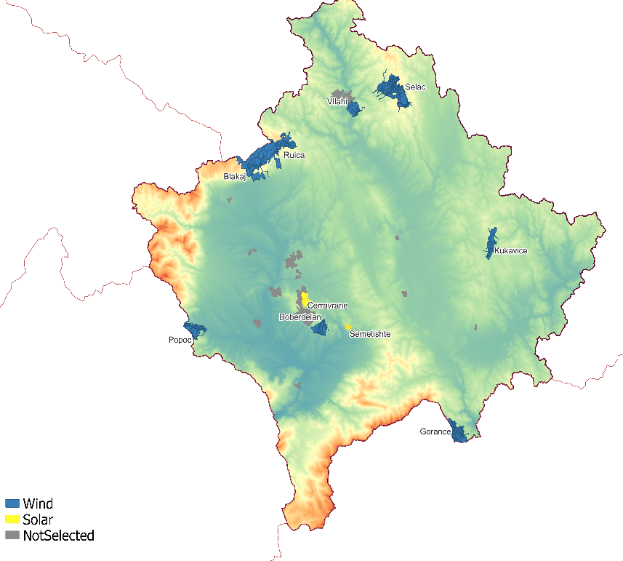
Total investment estimated:  - Preparatory activities (planning documentation, technical documentation, land acquisition, etc.)  - Construction works  - Supervision | Total investment: 100,000,000 EUR  Of which:  - Technical assistance for project preparation: 200,000 EUR  - Technical preparation of site specific projects, including wind measurements and EIA reports: 2,000,000 EUR  - Construction and works (70 MW): 95,800,000 EUR  - Contingencies: 2,000,000 EUR
Responsible or authorized person for contact: | Miftar Nika; Shqipe Gashi
Name – Position: | Miftar Nika - Head of Division for Renewable Energy Sources; Shqipe Gashi - Senior Officer for Renewable Energy Sources
Email address - Telephone: | Miftar.nika@rks-gov.net; Shqipe.n.gashi@rks-gov.net;  +383 38 200 215 20

- PROJECT DESCRIPTION
Purpose of the infrastructure project | The overall objective of this project is to ensure a reliable and clean energy supply in Kosova by increasing the share of renewable energy sources and facilitating the transition towards a decarbonized energy sector.  In line with our obligations deriving as a contracting party to the Energy Community Secretariat and the objectives outlined in the Energy Strategy 2022-2031, the project aims to:  - enhance the security of supply;  - increase the share of RES;  - reduce CO2 emissions;  - lessen the reliance on lignite for electricity generation.
Results of the infrastructure project | The following are the expected results of the project:  - Construction of publicly-owned wind power plant(s);  - Improved security of supply;  - Contribution towards achieving the approved target of a 32% RES-share as per Decision 2022/02/MC -EnC at the Energy Community Ministerial Council on 15 December 2022;  - Contribution towards attaining the target of 1300 MW of RES as set in the Energy Strategy for the period of 2022-2031;  - Improved environmental protection through the reduction of harmful greenhouse gas (GHG) emissions and carbon dioxide (CO2) emissions;  - Diversified energy sources in the electricity production;  - Decreased reliance on electricity imports.
General description | Snapshot of the power sector in Kosova (electricity generation, RES-share, energy crisis)  The power sector in Kosova is heavily reliant on lignite, with the majority of electricity generation coming from two old lignite-based thermal power plants: TPP Kosova A and TPP Kosova B.  The total electricity production in 2022 was 6,315 GWh, out of which 5,678 GWh were generated from lignite power plants accounting for 90% of domestic electricity production. The remaining, amounting to 637 GWh, was generated from renewable energy sources (RES). This represents a 1.7% increase in RES-based electricity production compared to 2021.  Currently, Kosova has an operational RES capacity of 279 MW, out of which 137 MW are generated from wind power plants. These wind power plants were primarily developed under the Feed-in Tariff (FiT) support scheme, granted through an administrative procedure based on a first-come, first-serve basis. Additionally, there are plans to construct 350 MW of solar photovoltaic (PV) capacity during 2023-2026. This will involve a combination of private and public investments, either on a merchant basis or through long-term contracts such as Power Purchase Agreements (PPAs).  In May 2024, Kosova concluded the first pilot auction and signed the contract for the construction of the 100 MW solar PV plant in Kramovik., and there are plan to initiate several other tenders in the near future  Due to insufficient domestic supply, unreliable power plants, the energy crisis negatively impacted the power sector in Kosova via electricity imports. Hence, the construction of wind generating capacities is expected to improve the security of supply.  Wind Power Plant project:  In this context, the Ministry of Economy has initiated a feasibility study under the Western Balkans Investment Framework Infrastructure Project Facility Technical Assistance 7 (IPF 7).  The purpose of this study is to identify the most suitable public land for the construction of wind and solar plants, utilizing either public investments or private investments through transparent and competitive processes – such as auctions.  In this study, thirteen (13) wind locations have been identified, out of which eight (8) locations have been selected in this phase based on their comparable low development risks for wind projects. This selection took into account various a set of criteria and parameters such as:  - Distance from the transmission grid;  - Availability of transmission capacities;  - Analysis of terrain orography (slope, exclusion of protected area and unsuitable area such as built-up sites, agricultural land, infrastructure and water bodies);  - Wind resource, in terms of an average wind speed.  The ongoing analysis of the feasibility study for the eight selected locations includes:  - Conducting walk-over and drone imaging for the inspection of selected sites;  - Clarification of ownership issues within the identified locations;  - Conducting environmental assessments, and;  - Performing connection analysis such as power flow analysis (N-1), grid code compliance, short circuit simulation, and transient stability analysis.  The study is expected to be completed in Q1 2024. Simultaneously, a publicly owned entity (POE) will be established to manage the assets. Upon completion of the study, the Ministry will possess a detailed database of the eight (8) wind locations, including detailed analysis of grid connections, ownership information, information on wind resource potential and other relevant terrain information.  The Ministry will then proceed with additional actions, including commencing a detailed Environmental and Social Impact Assessment (ESIA) report, procuring wind measurement devices, and undertaking other technical preparations for the construction of the wind farm, as well as focus on capacity building within the established POE.  The exact capacity and plant layout for each location will be determined once all the exact technical studies and solutions are finalized. The installed capacity may range from approximately 50 MW to 200 MW, although for the purpose of analysis in this early stage, an average capacity of 70 MW will be used as a reference for price calculation.

- ELIGIBILITY
Coherence with valid EU policies and strategies | DIRECTIVE (EU) 2018/2001 OF THE EUROPEAN PARLIAMENT AND OF THE COUNCIL of 11 December 2018 on the promotion of the use of energy from renewable sources  Article 3 - Overall Energy Community target for 2030  - Contracting Parties shall ensure that the share of energy from renewable sources in the Contracting Parties’ gross final consumption of energy in 2030 contributes to the overall Energy Community target set in part A of Annex I (Target for share of energy from renewable sources in gross final consumption of energy, 2030 for Kosova is 32%);  - The European Union shall endeavor to support the high ambition of Contracting Parties through an enabling framework comprising the enhanced use of available funds, including additional funds to facilitate a just transition of carbon-intensive regions towards increased shares of renewable energy, in particular financial instruments, especially for the following purposes:  (b) developing projects and programs for integrating renewable sources into the energy system.  Article 15 - Administrative procedures, regulations and codes  Contracting Parties shall ensure that any national rules concerning the authorisation, certification and licensing procedures that are applied to plants and associated transmission and distribution networks for the production of electricity, heating or cooling from renewable sources, to the process of transformation of biomass into biofuels, bio-liquids, biomass fuels or other energy products, and to renewable liquid and gaseous transport fuels of non-biological origin are proportionate and necessary and contribute to the implementation of the energy efficiency first principle  EUROPEAN COMMISSION Communication on an Economic and Investment Plan for the Western Balkan  V: Investing in clean energy  Support in the field of energy will be reinforced. Strong emphasis will be put on energy market integration, decarbonisation and clean energy, just transition, increased digitalization of the system, and smart grid energy efficiency, including modernization of district heating, and energy security. Decarbonisation is a key pillar of this Economic and Investment Plan in line with the aims of the European Green Deal. Enhanced connectivity and extension of the Energy Union to the Western Balkans will also be instrumental for a successful clean energy transition in the region.  SOFIA DECLARATION ON THE GREEN AGENDA FOR THE WESTERN BALKANS  Climate, energy, mobility  - Set forward-looking 2030 energy and climate targets in line with the Energy Community framework and EU acquis, as well as develop and implement integrated Energy and Climate Plans with clear measures designed to reduce greenhouse gas emissions in the Western Balkans economies by integrating climate action into all relevant sectorial policies;  - Increase the share of renewable energy sources and provide the necessary investment conditions, in line with the EU and Energy Community acquis and target.
Contribution to valid national development objectives | National Development Strategy 2030  6.3. Green Agenda  In this regard, resource efficiency relies on the economic development of low emissions, promoting energy enhancements, energy efficiency and renewable sources to reduce carbon emissions and dependence on fossil fuels, improving transportation and mechanisms to rely less on pollution.  National Development Plan 2030  3.3 Increasing the participation of renewable sources in the energy mix  Government Programme 2024-2026  Point 2.1: Enhancing energy supply security, sustainability and affordability  Increasing the variety of energy resources and creating favourable conditions for the supply of sustainable and affordable energy, for all citizens and enterprises in Kosova, considering the impact on the environment.
Is the project covered by the relevant sector strategy, by a Sector Action Plan or by a Sector Master Plan? | Energy Strategy of the Republic of Kosova 2022-2031  Strategic objective 2: Decarbonisation and promoting renewable energy  Specific objective 2.2: Promoting renewable energy in electricity consumption  Increasing the share of renewables in the electricity sector is fundamental to reach the decarbonisation targets and ensuring a just energy transition in Kosova. Diversifying the energy mix is vital for Kosova’s decarbonisation efforts and maintaining the security of the supply. Increase local capacity for power generation from renewable sources.  The path of reducing CO2 emissions of the sector will be accompanied by the development of large scale RES capacities, based on their technical and economic potential. The reduction of lignite-based electricity generation contributes to reducing pollution and GHG emissions, but its effects on security of supply and generation adequacy are offset by relying increasingly on domestic clean sources of energy.  New RES capacities, with existing and innovative technologies, will gradually replace the use of coal, achieving coal phase-out by 2050 at the latest.  Energy Strategy Implementation Plan 2022-2025  Strategic objective 2: Decarbonisation and promoting renewable energy  II.2. Specific objective: Promoting renewable energy in electricity consumption  II. 2.10. Action: Feasibility study on the identification of public owned land suitable for PV and wind (phase three).

- STRATEGIC RELEVANCE
Explain the features of the project in terms of:
Its inclusion in the latest PECI list | No.
Its coherence with ENTSO-E, ENTSOG infrastructure development plans | No.
Its contribution to Improving security of supply | By increasing the share of RES in the electricity generation, the project directly contributes to improving the overall security of supply.
Its impact on the improvement of local infrastructure | It will improve the grid on the local level in Kosova.
Enhancement of renewable energy sources and/or energy efficiency | This project would provide new additional installed capacity of renewable energy sources, which would have a direct impact on increasing the share of renewables in the electricity sector.
Reduction of CO₂ emissions | It has a positive impact on reducing CO₂ emissions.
Its contribution to overall economic growth | It will improve economic growth by investing in long-term capital investment and creating new jobs for the citizens of Kosova.
Integration with other projects | No.
The risks associated with the project | The non-realization of this project will enable the continued dependency of electricity production from lignite, and this will further endanger the security of the power supply.  Also, the risk for the project is the timeframe of project development, inflation and lack of institutional capacities in implementing new projects such as wind farms.

Part Two
- MATURITY
Available studies and documents | Ready and approved | Being worked on | Not started yet
Conceptual idea |  | X
Pre-feasibility study |  | X
Conceptual design |  |  | X
Feasibility study + CBA |  | X
EIA study (if needed) |  |  | X
Valid spatial planning documents |  |  | X
Land property resolved |  | X
Preliminary design |  | X
Main design/detailed design |  |  | X
Tender documentation |  |  | X
Construction and other permits |  |  | X
Construction contract signed |  |  | X

- DETERMINATION OF SOURCE OF FUNDING
 | Yes | Justification | No
Does the project enhance connectivity? | X
Does the project have cross-border impact or impact on other countries in the region? | X | It has a regional impact as it enhances the security of supply through regional market integration and supports competitiveness goals by optimizing wholesale and reserve markets for improved efficiency.
Can the project in any other way be earmarked as a regional project? |  |  | X

- SPENDING SCHEDULE
 | 2023 | 2024 | 2025 | 2026 | 2027 | 2028 | 2029 | 2030
Costs (in EUR) of: | - | 500,000 | 500,000 | 1,000,000 | 50,000,000 | 45,000,000 | 2,800,000 | 200,000
Project preparation (TA) | - | 500,000 | 500,000 | 1,000,000
Investment |  |  |  |  | 50,000,000 | 45,000,000 | 2,800,000 | 200,000

