Project Identification Form (PIF): Transport Sector

Part One

- GENERAL INFORMATION
Project title: | Construction of the Motorway Route 7 (Qafë Duhël - Shtime – Lipjan), 31 km
Sector | Transport
Subsector* (see list on the last page) | Road
Lead project Beneficiary/proponent: | Ministry of Environment, Spatial Planning and Infrastructure (MESPI)
Institution that is the author of the project proposal | MESPI
Location/Map | 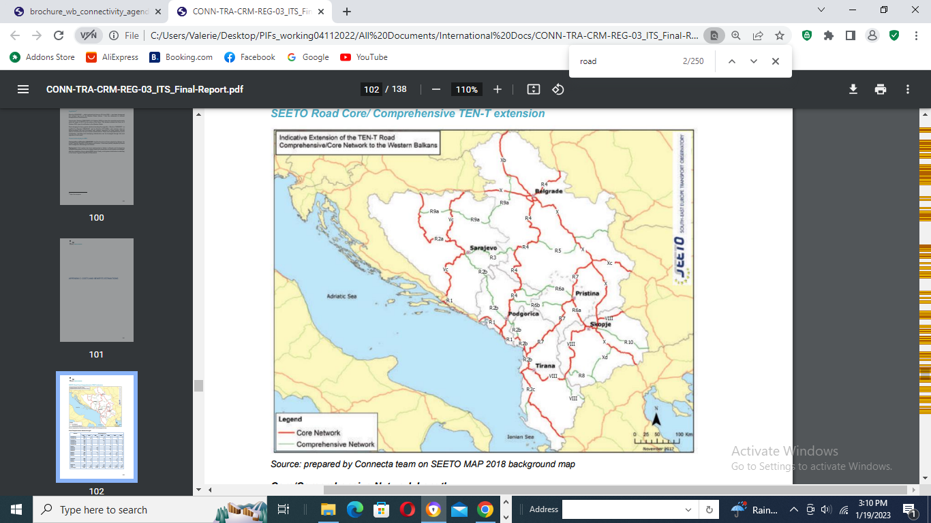
Total investment estimated:  - Preparatory activities (planning documentation, technical documentation, land acquisition etc.)  - Construction works  - Supervision | Total investment: 425,000,000.00 EUR  Of which:  - Preparatory activities: 18,000,000.00 EUR  - Construction works: 400,000,000.00 EUR  - Supervision of works: 7,000,000.00 EUR
Responsible or authorized person for contact: | Rexhe Osmanaj
Name – Position: | Rexhe Osmanaj – Acting Director of Infrastructure Department
Email address - Telephone: | Rexhe.Osmanaj@rks-gov.net, 044 220 517

- PROJECT DESCRIPTION

Purpose of the infrastructure project | The Project is located on the extension of Pan-European Corridor X / branch X c/. It has an obvious strategic dimension from a regional aspect, which is the reason for being confirmed as one section of Route 7 in the comprehensive core transport network defined by SEETO.  The overall objective of the project is to support transport infrastructure development as well as reform processes in the transport sector in Kosova and the region in line with the relevant EU Directives and Regulations.  The specific objective of the project is the continuation of the Motorway – Route 7 that starts from Albania/Kosova border and ends on the intersection exit Prishtina North. With the implementation of this section, Route 7 will be finalized, and the section from Prishtina South Exit to Prishtina North Exit will be fully functional. The core regional transport network of South East Europe was established by the REBIS project (Regional Balkans Infrastructure Study) financed by the EU and adopted in 2003 by the governments of the region. Two routes of this network pass through Kosova, namely:  • Route 6 connecting Corridor VIII in North Macedonia (Skopje) via Prishtina to route 4 in the eastern part of Montenegro;  • Route 7 connecting Corridor X in Serbia (Nis) via Prishtina to the Adriatic/Ionian coast in Albania.  The construction of the highway between Qafë Duhël - Shtime - Lipjan (segment of Route 7) is considered as a regional project connecting Kosova and neighbouring countries; it contributes to regional cohesion and will assist in the development of seamless connections for passengers and freight in the Western Balkans. This is the main direct road connection between Albania, Serbia and Kosova, which would ensure smooth flow of people and goods.
Results of the infrastructure project | The realization of the project will have direct impact on the improvement of the road connection with Albania, North Macedonia and Serbia and will contribute to the integration of Kosova into the transport system of the region and the entire Europe. Also, in the region of Southeast Europe, this project contributes to the significant increase of the volume of transit traffic between the SEETO network and the rest of Europe. This project will also result in the following:  - reduction of travel times;  - reduction of road infrastructure maintenance costs;  - cost efficiency regarding environmental protection, accidents and congestions at border crossing Merdare and urban area near the existing road in comparison to competitive roads;  - fostering of development of Western Balkans through improved connections;  - economic growth and social development;  - facilitation of trade and economic links with neighboring countries and EU member states;  - improvement of road and travel conditions in accordance with EU and SEETO priorities,  - provision of safe and reliable trips and road capacity improved.  The result of the updating of the feasibility study will be to establish spatial, environmental, social, financial and economic justification for the investment, create the basis for making the decision on investment justification and initiate the procedure for issuing the construction approval. It will also define the purpose, position, alignment, cross section, capacity, technical, technological and functional characteristics of Route 7.
General description | The segment Qafë Duhël - Shtime - Lipjan (31 km) is the last section of Route 7, and upon completion of the ongoing Route 6, Kosova will have a quick and safe connection with Corridor X and Corridor VIII. This will increase the in and out traffic in Kosova which will lead to more incomes through relaxation of transport for trade markets and facilitating tourism for Kosova itself, or as transit road for Adriatic/Ionian seaside in Albania. Route 7 can also be used as an alternative route to Corridor X and VII, as it provides a fast connection of Serbia with the Adriatic/Ionian coast, maintaining the same safe road conditions.  Part of Route 7 is constructed from Vërmicë (border to Albania) up to Prishtina and the road is open for transport since 2013. These routes constitute the main links to the neighboring capital cities and to the regional transport network in South East Europe. At the same time, they connect some of the main cities and economic centers within Kosova. In 2006 the preparation of a comprehensive feasibility study and environmental assessment of the two routes was commissioned by the Ministry of Industry, Entrepreneurship and Trade (MIET). The study was undertaken by a consortium led by COWI A/S (Denmark).  The construction of the road connecting Qafë Duhël - Shtime – Lipjan represents a logical continuation of the construction works on Route 7.  The current and urgent need in order to move towards the construction of the new road is the update of the Feasibility Study in parallel with the update of the Preliminary Design for Route 7 in Kosova, from Qafë Duhël - Shtime – Lipjan (length of 31 km) in order to connect with the existing highway Prishtina – Albanian border (Vërmicë).

- ELIGIBILITY

Coherence with valid EU policies and strategies | An Economic and Investment Plan for the Western Balkans, Brussels, 6.10.2020, states that “the EU will prioritize projects and programs on the indicative extension of the Trans European Transport Network (TEN-T) core network which are of strategic interest to the region and to the EU.” Also, the Plan states that fast and efficient transport links, both within the region and with the neighboring EU Member States, and sustainable transport with further investment in rail and inland waterways are crucial. This promotes “further regional cooperation and integration, connecting capitals in the region and with the EU.”  The Instrument for Pre-Accession Assistance (IPA III) 2021-2027 states that the improvement of the sustainable connectivity within the IPA III beneficiaries, as well as between them and the European Union, is a key factor for growth and will bring clear benefits for the region’s economies and citizens. The transport sector has a strong potential to contribute to competitiveness and trade. Competitive, sustainable and environmentally friendly transport solutions will require efficiently combining transport modes by road, rail, maritime and inland waterways. IPA III will also devote attention to transport safety and security, especially in road transport, and passengers’ rights in accordance with the EU requirements and targets to reduce road fatalities and serious injuries. Also, IPA III will support the construction of new transport infrastructure and the upgrading of existing infrastructure, with the objective of bringing the core transport network up to EU standards. It will also support intermodal connections and the gradual shift from individual road transport to public or shared mobility.
Contribution to valid national development objectives | The project is in line with the Stabilisation and Association Agreement (SAA), between Kosova and the European Union as stated in Article 113 of this agreement:  “Cooperation between the Parties shall focus on priority areas related to the EU acquis in the field of transport. Cooperation may notably aim at restructuring and modernizing Kosovo’s transport systems and improving related infrastructures (including regional links as identified by the South-East Europe Transport Observatory), improving the free movement of passengers and goods, achieving standards interoperable with and comparable to those prevailing in the EU and aligning transport legislation to that of the EU, should objective circumstances so permit. Cooperation shall aim to contribute to progressive mutual access to the EU and Kosovo transport markets and facilities as provided for in this Agreement, developing a transport system in Kosovo compatible, interoperable and aligned with the EU system, and improving environmental protection in the field of transport.”  EU Country Report for Kosovo 2023 states that “Kosovo should implement CONNECTA report recommendations to improve the quality of the road network and actions.”  National Programme for European Integration 2023-2027 promotes modern road and rail infrastructure, in order to connect to the Pan-European corridors. One of the main governmental priorities is investment in road infrastructure.  Economic Reform Programme 2024-2026, reform measure 13 concerns the further development and modernization of transport.
Coherence with national Transport Sector Strategic framework | Multi-Modal Transport Strategy 2030 aims to bring a sustainable and integrated transport system by strengthening different modes (road, rail and air), such as convenience, speed, cost, reliability, predictability, etc., and in combination, can offer more efficient transport solutions for people and goods which will help ease the pressure in our congested roads, and make the whole sector more environmentally friendly, safer, and cost-effective.

- STRATEGIC RELEVANCE

Explain the features of the project in terms of:
Improving inter-modality | There is a strong commitment from the Government of Kosova to improve the inter-modality aspect of the transport system in Kosova. Construction of Route 7 should be considered in a wider sense when it comes to inter-modality, as a trigger for construction of intermodal centers. Namely, through the construction of the highway section between Qafë Duhël - Shtime - Lipjan, the economically active zones in that part of Kosova could develop into intermodal nodes which would boost socio-economic development, not only for the country itself (Kosova) but also for neighboring countries, such as Serbia and Albania, as this Route facilitates Serbia in access to Adriatic/Ionian coast.
Increasing international traffic (freight, persons) | Construction of Route 7 section Qafë Duhël - Shtime - Lipjan with connection to Corridor X E-75 will contribute to the development of the network capacity, resulting in faster integration of Route 7 into the Pan-European and Regional system / Comprehensive Network of SEE. It is justifiably expected that traffic of people and goods will be significantly increased.
Being included in the latest Multi-annual plan (MAP) of SEETO | It is included in the latest Multi-annual plan (MAP) of SEETO, http://www.seetoint.org/library/multi-annual-plans/
Providing connection to TEN-T corridors | The Project is located on the extension of Pan-European Corridor X / branch Xc/. It has an obvious strategic dimension from a regional aspect, which is the reason for being confirmed that this section of Route 7 falls in the core transport network defined by SEETO.
Its contribution to Improvement of safety conditions | Construction of the highway Qafë Duhël - Shtime - Lipjan will significantly improve safety conditions on this part of the road network of Kosova. Namely, by construction of the highway with the contemporary safety standards the number of accidents will be significantly reduced, which is now caused by the road passing through the highly populated and economically active region of Kosova.
New, upgraded or rehabilitated infrastructure | New infrastructure will be constructed following the new alignment.
Meeting annual traffic demand growth | Annual traffic growth is 6 % at the moment. According to the feasibility study the new road characteristics will accommodate the growing traffic.
Time reduction for journeys | Construction of the highway between Qafë Duhël - Shtime - Lipjan will create significant journey time reduction.
Its effect on the reduction of CO₂ and noise emissions | Yes, based on the previous/preliminary ESIA done in 2006 by COWI.
Its contribution to overall economic growth | The project would create significant economic growth potential, according to SEETO estimations; EIRR is 8.25%, which is considered significant in the Western Balkans.
Its integration with other projects | The project is integrated with the completed section of the highway which connects Prishtina with Kukës and Durrës in Albania, which will shorten the distance to connect to Corridor X.  Therefore, this project is considered as a continuation of the investment in the modernization of the road transport network of Kosovo.  In addition, Route 7 will connect western Kosova through Route 6 with Corridor VII, providing further integration with current and upcoming projects.
The existence of alternatives | In the Feasibility Study possible alternative options are analyzed and the selected option is proven as the most adequate and feasible one.

Part Two

- MATURITY

Available studies and documents | Ready and approved | Being worked on | Not started yet
Conceptual idea | X
Pre-feasibility study | X
Conceptual design | X
Feasibility study + CBA | X
EIA study (if needed) | X
Valid spatial planning documents | X
Land property resolved |  |  | X
Preliminary design | X
Main design/detailed design |  |  | X
Tender documentation |  |  | X
Construction and other permits |  |  | X
Construction contract signed |  |  | X

- DETERMINATION OF SOURCE OF FUNDING

 | Yes | Justification | No
Does the project enhance connectivity? | X | This is a regional project connecting Kosova, Albania, and Serbia; it contributes to regional cohesion and will assist in the development of seamless connections for passengers and freight in the Western Balkans.
Does the project have cross-border impact or impact on other countries in the region? | X | This is one of the main direct road connections between Albania, Serbia and Kosova, mainly used for freight transport.
Can the project in any other way be earmarked as a regional project? | X | The project connects to countries in the region such as Albania and Serbia and also provides a connection to Corridor X, E-75 further connecting Kosova with the rest of Europe.

- SPENDING SCHEDULE

 | 2015-2020 | 2021 | 2022 | 2023 | 2024 | 2025 | 2026 | 2027 | 2028 | 2029 | 2030
Costs (in mEUR) of which: |  |  |  |  | 5 | 13 | 152 | 153 | 102
Project preparation (TA) |  |  |  |  | 5.0 | 13.0 | 2 | 3 | 2
Investment |  |  |  |  |  |  | 150 | 150 | 100

- OTHER ASPECTS

Have IFIs or other donors already been consulted on the project? When? What was their judgement? | A donor consultation meeting took place on 10 May 2023, where IFIs and other donors were invited to participate in a general discussion on the projects in the Transport sector SPP prior to its validation and approval. EBRD is ready to support the project as Lead IFI.
Existing EU or WBIF support (TA): amount, purpose | Not at this time.
Has the Ministry of Finance already been consulted on the project? Describe feedback. | Yes, they have endorsed the project.
Does the project generate revenues from end users? | Possibly in the future as part of the whole corridor.
Description of project team for implementation | PIU is existing for all project investments from grants and loan agreements.

