Project Identification Form (PIF): Transport Sector
Part One

- GENERAL INFORMATION

Project title: | General rehabilitation and modernisation of Railway Route 10 (Border with Serbia – Leshak – Fushë Kosovë – Hani i Elezit – Border with North Macedonia), 149.11 km
Sector | Transport
Subsector* (see list on the last page) | Rail
Lead project Beneficiary/proponent: | Ministry of Environment, Spatial Planning and Infrastructure (MESPI); Ministry of Economy (ME)  Kosova Railways Infrastructure JSC – INFRAKOS
Institution that is the author of the project proposal | Kosova Railways Infrastructure JSC – INFRAKOS, MESPI
Location/Map | 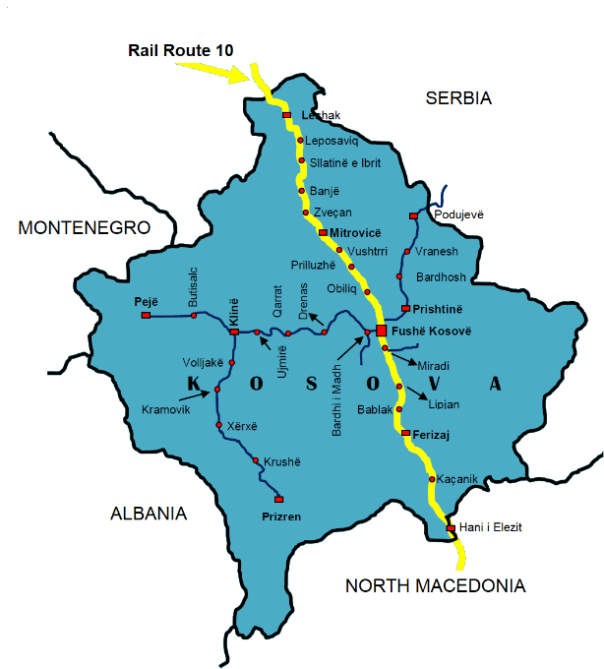
Total investment estimated:  - Preparatory activities (planning documentation, technical documentation, land acquisition etc.)  - Construction works  - Supervision | Total investment: 323,765,000.00 EUR  Of which:  - Preparatory activities: 4,998,000.00 EUR  - Construction works: 307,678,000.00 EUR  - Supervision: 11,089,000.00 EUR
Responsible or authorized person for contact: | Naser Krasniqi
Name – Position: | CEO of Kosova Railways Infrastructure JSC - INFRAKOS
Email address - Telephone: | naser.krasniqi@kosovorailway.com;  +383 38 550 550 505

- PROJECT DESCRIPTION

Purpose of the infrastructure project | The existing railway lines in Kosova are in poor condition. The governmental strategy is to develop railway transport, in this context especially Railway Route 10. Therefore, the specific objective of this project is to rehabilitate and modernize Railway Route 10 in order to increase safety, speed, capacity, and have interoperable railway infrastructure based on EU standards through which will support safe railway transport and railway market opening for domestic, regional and international railway undertakings.  Railway Route 10 project is with high interest for Kosova and the regional economic, social and environmental benefit. Kosova businesses and industry will have potential growth and better connections with Serbia, North Macedonia and wider regional businesses. This project is of high social and economic interest given that connectivity, especially transport links, contributes to growth by enabling movement of goods, services, capital, people and information across countries.  Through the implementation of this project, Kosova will have good connection with regional railways and Pan-European corridors, an increased number of people with improved access to services; and an increased number of employed people during construction phase and through operation and maintenance.
Results of the infrastructure project | Developing this project, INFRAKOS will realize needed general rehabilitation and modernization of this line in order to have interoperable railway infrastructure through which safe railway transport and railway market opening for domestic, regional and international railway undertakings will be supported. The main stakeholders affected by this project are the Public Railway Undertaking of Kosova (TRAINKOS) and all other railway undertakings (local, regional and EU) as potential users of this infrastructure in the future.  General rehabilitation of Railway Route 10 is a precondition for the development of the railway sector in Kosova, and implementation of this project will result in:  - Increased safety and speed conditions of this line;  - Interoperable railway infrastructure as a linkage between neighboring countries and the wider region;  - Better conditions for development of the passenger and freight transport;  - Increased economic growth and social development;  - Facilitated trade and economic links with neighboring countries and EU member states;  - Improvement of transport capacities;  - Development of multimodal and intermodal transport in Kosova and beyond;  - Being part of the Regional and EU Integrated Railway Network.
General description | Railway Route 10 sustained significant damages during the period 1990-1999, some of which have been partially repaired. The level of regular maintenance over the same period was reduced to a minimum resulting in the current sub-standard condition of the line. Maximum speeds have been reduced to 60-70 km/h and in some specific cases the maximum speed is as low as 20 km/h due to safety reasons (e.g. sections with tunnels).  The Railway Route 10 in Kosova includes a 149.11 km-long, single-track, standard gauge (1435 mm) non-electrified rail line in central Kosova. The rehabilitation will allow operation up to 120 km/h on most sections of the line along with 22.5-ton axle load in line with EU standards. These standards cannot be achieved without implementation of the project for general rehabilitation and modernization.  Railway Route 10 is part of the SEETO Core Network indicative extension to TEN-T and this line is an alternative line of Pan-European Corridor X, connecting Lapovo (Serbia) – Fushë Kosovë (Kosova) – Skopje (North Macedonia). It has an obvious strategic dimension from a regional aspect for the development of railway transport.  This is a regional project connecting Kosova and neighboring countries; it contributes to regional cohesion and will assist in the development of seamless connections for passengers and freight in the Western Balkans. This is the main direct railway connection between Serbia, Kosova and North Macedonia.  This ongoing project is split in three phases:  - Phase 1 - Section: Border with North Macedonia - Hani i Elezit - Fushë Kosovë;  - Phase 2 - Section: Fushë Kosovë – Mitrovicë;  - Phase 3-Section: Mitrovicë - Leshak - Border with Serbia.  In order to achieve projected speed and increase safety conditions, there is an immediate need for general rehabilitation and modernization of this line.  After general rehabilitation and modernization, the Railway Route 10 will fulfill Technical Specifications on Interoperability (TSI), European Railway Traffic Management System (ERTMS), and European Train Control System (ETCS - Level 1 with infill).

- ELIGIBILITY

Coherence with valid EU policies and strategies | Railway Route 10 is part of the SEETO Core Network indicative extension to the Trans European Transport Network (TEN-T). It has an obvious strategic dimension from a regional aspect for the development of the railway transport. Modernization of the rail infrastructure by connecting to Pan-European corridors is considered as one of the objectives of the Strategy for European Integration.  An Economic and Investment Plan for the Western Balkans, Brussels, 6.10.2020, states that “the EU will prioritise projects and programmes on the indicative extension of the Trans European Transport Network (TEN-T) core network which are of strategic interest to the region and to the EU.” The Railway Route 10 is part of TEN-T core network. The Plan foresees that “CONNECTING NORTH TO SOUTH: Major north to south connections will be completed or advanced by 2024 - Railway Route connecting Belgrade with Prishtina will be further upgraded through construction works in Kosova and by preparing the necessary technical documentation for the rehabilitation works in Serbia.”  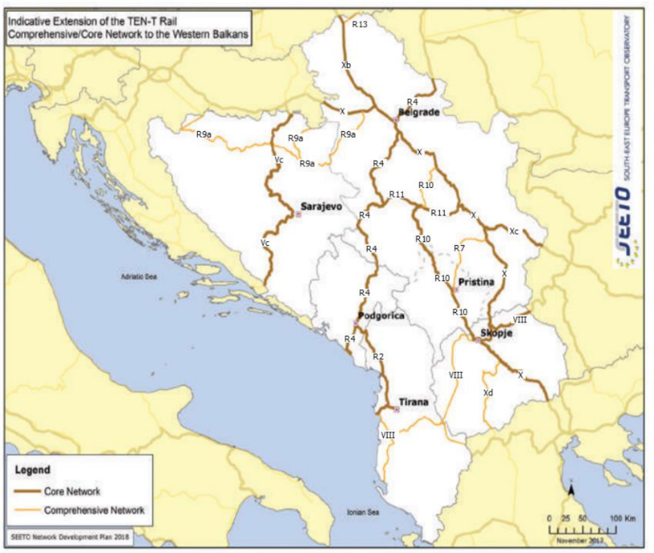  Also, the Plan states that fast and efficient transport links, both within the region and with the neighboring EU Member States, and sustainable transport with further investment in rail and inland waterways are crucial. This promotes “further regional cooperation and integration, connecting capitals in the region and with the EU” and promotes “multimodal transport solutions and modal shift, and reducing transport related pollution.” Thus, the Plan foresees that “action will be taken to speed up construction of new transport infrastructure and the upgrading of existing infrastructure, with the objective of bringing the core transport network up to EU standards.”  According to the European Green Deal, Brussels, 11.12.2019,  “a substantial part of the 75 per cent of inland freight carried today by road, needs to be shifted to rail and inland waterways.”  Guidelines for the Implementation of the Green Agenda for the Western Balkans, Brussels, 6.10.2020, considers the revitalization of rail network as a top priority and that the promotion of multimodal transport solutions and modal shift, through targeted policies, including investment in inland waterways, is needed. Also, it states that “implementation of EU technical standards in all transport modes, in particular the European Railway Traffic Management System” should be ensured.  A credible enlargement perspective for and enhanced EU engagement with the Western Balkans, Strasbourg, 6.2.2018, states that “it is a political priority to connect infrastructure also between the EU and the Western Balkans and to accelerate the development of interconnected trans-European networks in the fields of transport, energy and digital services.”  Sustainable and Smart Mobility Strategy, Brussels, 9.12.2020, states: “Mobility in Europe should be based on an efficient and interconnected multimodal transport system, for both passengers and freight, enhanced by an affordable high-speed rail network, by abundant recharging and refueling infrastructure for zero-emission vehicles and supply of renewable and low-carbon fuels, by cleaner and more active mobility in greener cities that contribute to the good health and wellbeing of their citizens.” The same strategy foresees that by 2030 high-speed rail traffic will double, and by 2050 rail freight traffic will double whereas high speed rail traffic will triple. Also, it is foreseen that “the multimodal Trans-European Transport Network (TEN-T) equipped for sustainable and smart transport with high speed connectivity will be operational for the comprehensive network.”  Strategy for Sustainable and Smart Mobility in the Western Balkans, July 2021 states that “Interventions are required to increase railway capacity and enable more competitive rail services”. Also, the Strategy states that:  - By 2023, InterCity Rail transport between capitals in the Western Balkans, on existing connections, should be re-established;  - By 2030, rail freight traffic to increase by 20 percent. This to double by 2050;  - By 2035, the Core Rail Network to be compliant with TEN-T standards;  - By 2035, rail and waterborne-based intermodal transport to compete on equal footing with road-only transport in the Western Balkans.  The EU’s Fourth Railway Package (2013) foresees improving the interoperability and safety of national networks and developing rail transport infrastructure.  One of the objectives of EBRD stated in Transport Sector Strategy (2019-2024), October 2019, is “investment in rehabilitation and expansion of national, regional and sub-urban rail infrastructure and signaling, to improve access to markets and services, and create linkages to key transport networks and corridors, including TEN-T, WBCN, CAREC, TRACECA and BRI in the economies where the Bank invests.”  The Instrument for Pre-Accession Assistance (IPA III) 2021-2027, states: “The improvement of the sustainable connectivity within the IPA III beneficiaries, as well as between them and the European Union, is a key factor for growth and will bring clear benefits for the region’s economies and citizens. The transport sector has a strong potential to contribute to competitiveness and trade. Competitive, sustainable and environmentally friendly transport solutions will require efficiently combining transport modes by road, rail, maritime and inland waterways. There is therefore a particular need for greater multimodality, decarbonization and electrification.” A modern network of infrastructure will serve little purpose if the institutional and regulatory frameworks are not strengthened and aligned with EU requirements. In the transport sector this means providing support to promote efficient and sustainable management of the physical assets, introducing EU-compliant technical standards, simplifying border crossing procedures and enhancing the capacity of border crossing points. It also means road completion, maritime, railway and air market reforms. Also, it is mentioned that “Fast and efficient transport links, both within the region and with the neighboring EU Member States, and greening transport with further investment in rail and waterways are crucial. In this context, to further spur regional cooperation and integration, connecting capitals in the region and with the EU will be an important priority.”  This project is also in compliance with the Treaty establishing the Transport Community (2017), which among others describes the need for the indicative trans-European transport network (TEN-T) extension of comprehensive and core networks to the Western Balkans.
Contribution to valid national development objectives | Improving connectivity within our region as well as with the EU is a key factor for growth and jobs in the WB. Through the implementation of this project, INFRAKOS and the Ministry of Environment, Spatial Planning and Infrastructure will fulfil part of their development strategies. Modernization of the rail infrastructure by connecting to Pan-European corridors is considered as one of the governmental objectives of the National Programme for European Integration 2023-2027.  The project is in line with the Stabilisation and Association Agreement (SAA), between Kosova and the European Union as stated in Article 113 of this agreement:  “Cooperation between the Parties shall focus on priority areas related to the EU acquis in the field of transport. Cooperation may notably aim at restructuring and modernising Kosovo’s transport systems and improving related infrastructures (including regional links as identified by the South-East Europe Transport Observatory and followed by Transport Community Treaty), improving the free movement of passengers and goods, achieving standards interoperable with and comparable to those prevailing in the EU and aligning transport legislation to that of the EU, should objective circumstances so permit. Cooperation shall aim to contribute to progressive mutual access to the EU and Kosovo transport markets and facilities as provided for in this Agreement, developing a transport system in Kosovo compatible, interoperable and linked with the EU system, and improving environmental protection in the field of transport.”  In the Program of the Government of the Republic of Kosova 2021 – 2025, the government stresses its commitment to create an integrated system for road, rail and air transport, for the purpose of economic development, and to modernize and develop the railway infrastructure in order to provide more sustainable services.  Economic Reform Programme 2024-2026 foresees that further connectivity with neighboring countries would strengthen the country’s integration into the regional market.  National Programme for European Integration 2023-2027 promotes modern and better regional railway infrastructure, in order to connect to the Pan-European corridors.  Strategic and Operational Plans of the Government of Kosova 2021-2025 foresee rehabilitation and modernization of Railway Route 10.  EU Country Report for Kosovo 2023 states: “Kosovo should implement the pending connectivity projects and strengthen institutional and administrative capacities for the implementation of strategic infrastructure projects.”  Medium Term Expenditure Framework 2022-2024 states that “Infrastructure will continue with investments in road and railway infrastructure of national and international importance, will also work to build infrastructure of national importance that connects the regions of Kosovo and those that ensure economic growth.”  The Government intends through development banks to finance the rehabilitation of the Railway Route 10, which allows cheaper transportation of people and goods. The European Bank for Reconstruction and Development (EBRD) granted a loan to the Government of Kosova for the infrastructure of Kosova Railways (INFRAKOS), to finance the emergency rehabilitation of Railway Route 10.
Coherence with national Transport Sector Strategic framework | Multi-Modal Transport Strategy 2030 aims to bring a sustainable and integrated transport system by strengthening different modes (road, rail and air), such as convenience, speed, cost, reliability, predictability, etc., and in combination, can offer more efficient transport solutions for people and goods which will help ease the pressure in our congested roads, and make the whole sector more environmentally friendly, safer, and cost-effective. Also, it is stated that “EU’s transport policy is naturally aligned with the global trends presented above. It can be emphasized though that there is a special attention being made towards the uptake of zero-emission vehicles, development of rail transport and the reinforcement of a single market which is based on the user-pays principle.” Also states that “Besides the low quality of infrastructure, Kosovo’s railway also lacks ERTMS. This is a key component of making railway traffic competitive and safe and thus all modernization projects should include deployment of ERTMS. As most accidents on railway happen on road-rail crossing, deploying ERTMS will also help to reduce the number of fatalities related to railway transport.”

- STRATEGIC RELEVANCE

Explain the features of the project in terms of:
Improving inter-modality | By implementing the general rehabilitation of this line, Kosova will improve and develop in highest level of intermodal transport on a local, regional and international level. This will facilitate “door to door” transport using railway and road vehicles through the existing freight terminal in Fushë Kosova node.
Increasing international traffic (freight, persons) | Railway Route 10 will facilitate connections for passengers and freight transport between the respective countries and at the same time improve conditions for transport.  Based on the Network Development Plan of INFRAKOS (2018), the percentage of passengers shifting from car to rail per scenario where Route 10 is rehabilitated in 2025 for the segment Mitrovicë – Leshak is 2%. The potential for shifting to rail is also larger if rail service is improved.  The yearly growth for GDP-related cargo (freight) is assumed as 4% (same as GDP growth rate), whereas OD forecast, rail cargo passing Kosovo/Serbia border, in year 2025 is 415,063 tons.  Current number of trains of Railway Route 10 as presented in Kosova railway time-table is 11 trains/24h, while forecasted number of trains (for period of next 10-15 y) is 56 trains/24h.
Being included in the latest Multi-annual plan (MAP) of SEETO | It is included in the latest SEETO Multi-Annual Plan (MAP).
Providing connection to TEN-T corridors | The line is connected with TEN-T Corridor through Lapovo in Serbia and Skopje in North Macedonia. Rail Route 10 branches from Lapovo (Serbia) between Belgrade and Nis (Corridor X connects to Belgrade via Lapovo) and forms an alternative route to Skopje: Belgrade - Lapovo - Kraljevo - Fushë Kosova - Skopje.
Its contribution to improvement of safety conditions | Rehabilitation of this line will be done in accordance with the contemporary railway safety standards. Having in mind the current condition of the respective railway line, this project will have significant impact on improvement of safety conditions.
New, upgraded or rehabilitated infrastructure | General rehabilitation and modernization of Railway Route 10.
Meeting annual traffic demand growth | The project meets the requested criteria for transport growth.
Time reduction for journeys | The Network Development Plan of INFRAKOS (2018) foresees that the time reduction for journeys in this line will for the southern part be about 104 min, where now a train form Leshak to Hani i Elezit arrives for 214 min.
Its effect on the reduction of CO₂ and noise emissions | Realizing this project will lead to the predominant part of road freight transport being shifted to railways which would have significant impact in respect to the reduction of CO₂ and noise emission.  This project has sustainability in relation to environmental aspects, due to the fact that trains have very low emission of C02 comparing with road vehicles.
Its contribution to overall economic growth | Improvement of transport infrastructure across the Western Balkans is a key element to ensure connectivity, sustainable economic growth and cohesion among the Regional Parties and European Union.  Enhancing connectivity within the Western Balkans represents a strategic interest for both sides. Increasing transport connections will allow for increased competitiveness, economic growth and security of supply, and is at the same time an important prerequisite for economic integration within the Western Balkans.  The Western Balkans are surrounded geographically by EU Member States and it is a political priority to connect infrastructure also between the EU and the Western Balkans and to accelerate the development of interconnected trans-European networks in transport.  Upgrading international railway network will help the export of minerals and agricultural produce. Improved transport infrastructure will also encourage new investment. The cumulative effect will be higher economic growth rates.
Its integration with other projects | This project is in direct connection with the investments on railway infrastructure in the region.
The existence of alternatives | In terms of alignment, there was no need for alternative analyses having in mind that the project is related to rehabilitation of the existing line. However, alternative options were explored when it comes to telecommunication, signaling and electrification options.

Part Two
- MATURITY

Available studies and documents | Ready and approved |  |  | Being worked on |  |  | Not started yet
Available studies and documents | Phase I | Phase II | Phase III | Phase I | Phase II | Phase III | Phase I | Phase II | Phase III
Conceptual idea | x | x | x
Pre-feasibility study
Conceptual design |  |  |  |  |  |  | N/A | N/A | N/A
Feasibility study + CBA | x | x | x
EIA study (if needed) |  |  |  |  |  |  | N/A | N/A | N/A
Valid spatial planning documents |  |  |  |  |  |  | N/A | N/A | N/A
Land property resolved | x | x | x
Preliminary design |  |  |  |  |  |  | N/A | N/A | N/A
Main design/detailed design | x | x |  |  |  | x
Tender documentation | x | x |  |  |  | x
Construction and other permits | x | x |  |  |  | x
Construction contract signed | x | x |  |  |  |  |  |  | x

- DETERMINATION OF SOURCE OF FUNDING

 | Yes | Justification | No
Does the project enhance connectivity? | x | The realization of the project will have direct impact on the improvement of the railway connection within Kosova, with regional countries and Integrated EU Network.
Does the project have cross-border impact or impact on other countries in the region? | x | This railway line has cross-border impact with Serbia and North Macedonia and also will have impact on other neighboring countries.
Can the project in any other way be earmarked as a regional project? | x | Taking into consideration the SEETO Comprehensive Railway Network and linkage to TEN-T, this project can be considered as a regional project, too.

- SPENDING SCHEDULE

 | 2015-2020 | 2021 | 2022 | 2023 | 2024 | 2025 | 2026 | 2027 | 2028 | 2029 | 2030
Costs (in EUR) of: | 15.2 | 15.1 | 23.5 | 67.2 | 56.5 | 56.5 | 60.2 | 29.565
Project preparation (TA) | 3.7 | 1.1 | 2 | 2.2 | 1.5 | 1.5 | 1.5 | 2.5
Investment | 11.5 | 14 | 21.5 | 65 | 55 | 55 | 58.7 | 27.065

- OTHER ASPECTS

Have IFIs or other donors already been consulted on the project? When? What was their judgement? | A donor consultation meeting took place on 10 May 2023, where IFIs and other donors were invited to participate in a general discussion on the projects in the Transport sector SPP prior to its validation and approval.
Existing EU or WBIF support (TA): amount, purpose | Ongoing:  -Detailed Design and Tender Preparation for the Northern Part of Railway Route 10 (Mitrovica - Lesak - Border with Serbia), EUR 3,239,873  -Detailed Technical Project Design and Tender Preparation for Fushë Kosovë/Kosovo Polje - Mitrovica Railway Line (Rail Route 10), EUR 1,000,000  Completed:  Works Supervision for Rehabilitation of Railway Route 10 Phase 1: Section Fushë Kosovë – Border with North Macedonia, EUR 1,400,000  Railway Route 10 Rehabilitation: Fushë Kosovë – Hani i Elezit Section, EUR 1,840,000  Rehabilitation of Railway Route 10 (Leshak – Mitrovicë – Fushë Kosovë – Ferizaj – Hani i Elezit), EUR 500,000
Has the Ministry of Finance already been consulted on the project? Describe feedback. | The Ministry of Finance, Labor and Transfers is informed and has endorsed the project.
Does the project generate revenues from end users? | This project is as a precondition for future developments and will generate revenues from railway undertakings.
Description of project team for implementation | INFRAKOS has established a Project Implementation Unit (PIU) for this project.

