Project Identification Form (PIF): Transport Sector

Part One

- GENERAL INFORMATION

Project title: | Expansion of the Regional Road R107 (Istog-Pejë-Deçan-Gjakovë-Prizren), 91 km
Sector | Transport
Subsector* (see list on the last page) | Road
Lead project Beneficiary/proponent: | Ministry of Environment, Spatial Planning and Infrastructure (MESPI)
Institution that is the author of the project proposal | MESPI
Location/Map | 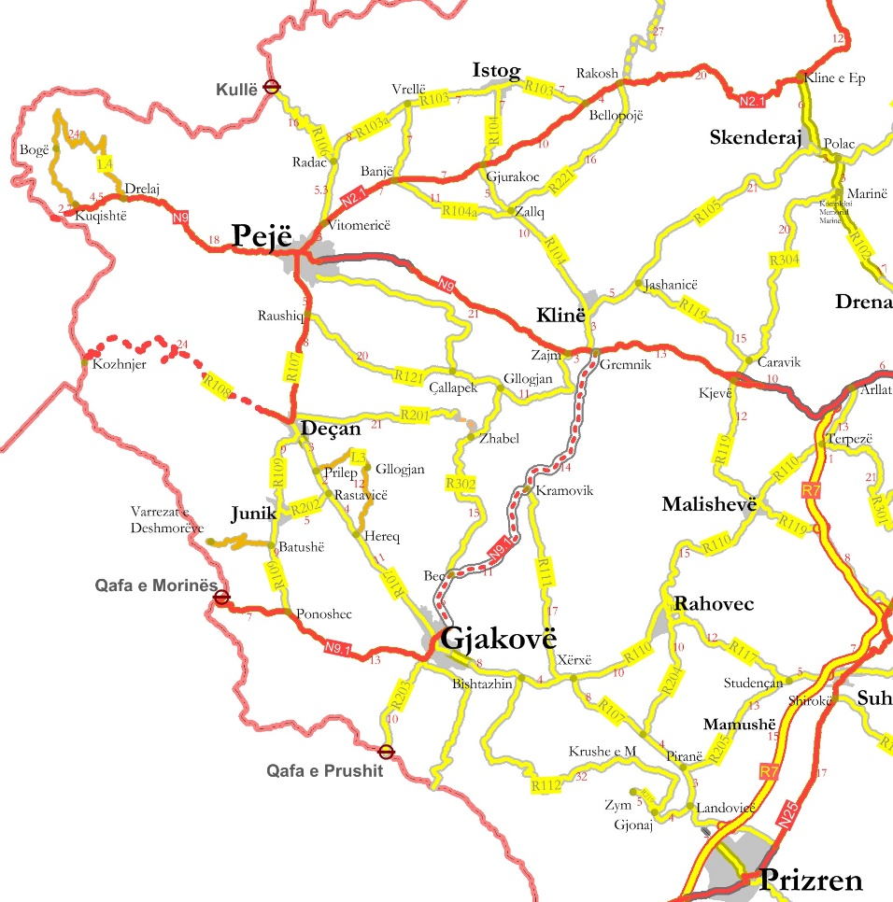
Total investment estimated:  - Preparatory activities (planning documentation, technical documentation, land acquisition etc.)  - Construction works  - Supervision | Total investment estimated: 225,000,000 EUR  Of which:  - Preparatory activities 3,350,000 EUR  - Construction works: 215,000,000 EUR  - Supervision: 6,650,000 EUR
Responsible or authorized person for contact: | Rexhe Osmanaj
Name – Position: | Acting Director of Infrastructure Department
Email address - Telephone: | Rexhe.Osmanaj@rks-gov.net , 044 220 517

- PROJECT DESCRIPTION

Purpose of the infrastructure project | The purpose of this project is the expansion of the Regional Road R107 Istog – Pejë – Gjakovë (91 km) in order to primarily improve safety conditions and to increase capacity by partial widening and upgrading of the road and construction partly additional lanes to allow overtaking.  This road currently has the largest national importance as it is connecting two major cities of Kosova, Peja in the northern part and Prizren in the southern part. Also the main part of the road that connects the city of Peja with the capital city Prishtina and continues towards the border with Montenegro is currently being widened and this will improve the link of the remaining part of the country with Montenegro.  This section of road connects also with Route 7 in Prizren and continuing to Durrës port in Albania, which will contribute to facilitate the freight transport of the country and neighbouring countries.  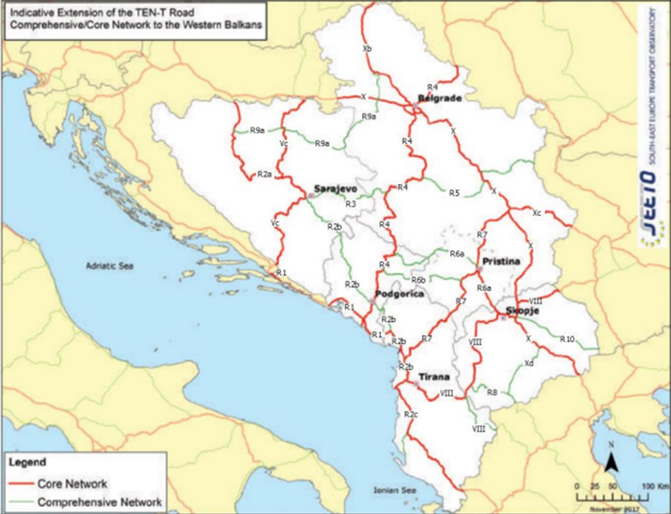
Results of the infrastructure project | The total length of this section is 91 km, with a variety of road alignments and conditions.  This regional road acts as an important link between the main regional cities in Kosova. Its importance for the national traffic is similar to the main roads, although it is not built to the same standards. This project consists of partial widening and upgrading of the road, and to create partly additional lanes to allow overtaking. It is in the priorities of MI. Two bypass roads around Deçan and Gjakova should be constructed.  Expansion of the Regional Road R107 Istog – Pejë – Gjakovë through the implementation of this project will result in:  - economic growth and social development;  - facilitate trade and economic links with its neighboring countries and EU member states;  - facilitate trade and travel between main cities in Kosova;  - improvement safety on the road;  - sustain the investment in the Transport Sector;  - improvement of the road and travel conditions in accordance to the EU and SEETO priorities;  - provide safe and reliable trips and road capacity improved;  - reduction of travel times and road infrastructure maintenance costs.
General description | Network development of regional and national roads is a key requirement for economic and social development of South -East Europe. It will strengthen ties with neighboring countries, accelerate the flow of international market and will provide a better connection with regional or remote areas of South -East Europe.  Regional roads have the role of completing the web of the network and make connections between the main corridors and connect localities or regions important in regional basis.  The rest of regional roads have an importance to national and even regional and small settlements, connecting them to the central network. Part of this is also the local road network that is not fully built but generates a lot of traffic.  The road is primarily a two-lane road at the moment, and it is planned to be widened to a four-lane freeway (width L= 20 m). In this section there are two new bypasses foreseen at the main cities: one in Deçan municipality and the other in Gjakova municipality.

- ELIGIBILITY

Coherence with valid EU policies and strategies | The Instrument for Pre-Accession Assistance (IPA III) 2021-2027 states that the improvement of the sustainable connectivity within the IPA III beneficiaries, as well as between them and the European Union, is a key factor for growth and will bring clear benefits for the region’s economies and citizens. The transport sector has a strong potential to contribute to competitiveness and trade. Competitive, sustainable and environmentally friendly transport solutions will require efficiently combining transport modes by road, rail, maritime and inland waterways, IPA III will also devote attention to transport safety and security, especially in road transport, and passengers’ rights in accordance with the EU requirements and targets to reduce road fatalities and serious injuries. Also, IPA III will support the construction of new transport infrastructure and the upgrading of existing infrastructure, with the objective of bringing the core transport network up to EU standards. It will also support intermodal connections and the gradual shift from individual road transport to public or shared mobility.
Contribution to valid national development objectives | Expansion of this national road is a country level project. connecting Kosova’s main cities in the western part of the country. It contributes to ease congestion and improve safety for the local and international traffic.  In the Program of the Government of the Republic of Kosova (2021 – 2025), the government stresses its commitment to the expansion of national roads Istog-Peja-Deçan-Gjakova-Prizren.  The project is in line with the Stabilisation and Association Agreement (SAA), between Kosova and the European Union, as stated in Article 113 of this agreement:  “Cooperation between the Parties shall focus on priority areas related to the EU acquis in the field of transport. Cooperation may notably aim at restructuring and modernising Kosovo’s transport systems and improving related infrastructures (including regional links as identified by the South-East Europe Transport Observatory), improving the free movement of passengers and goods, achieving standards interoperable with and comparable to those prevailing in the EU and aligning transport legislation to that of the EU, should objective circumstances so permit. Cooperation shall aim to contribute to progressive mutual access to the EU and Kosovo transport markets and facilities as provided for in this Agreement, developing a transport system in Kosovo compatible, interoperable and linked with the EU system, and improving environmental protection in the field of transport.”  EU Country Report for Kosovo 2023 states that “Kosovo should still implement CONNECTA report recommendations to improve the quality of the road network and actions.”  National European Integration Programme 2023-2027 promotes modern road and rail infrastructure, in order to connect to the Pan-European corridors. One of the main Kosova Government priorities is investment in road infrastructure.  Medium Term Expenditure Framework 2022-2024, April 2021 states that “Infrastructure will continue with investments in road and railway infrastructure of national and international importance, will also work to build infrastructure of national importance that connects the regions of Kosovo and those that ensure economic growth.”  Strategic and Operational Plan of the Government of Kosova (2022-2025) foresees the extension of the national roads Istog-Pejë-Deçan and Gjakovë-Prizren, including the circuit roads through the cities.  The Government intends through development banks to finance the rehabilitation of this railway line.
Coherence with national Transport Sector Strategic framework | Multimodal Transport Strategy 2030 states: “The biggest possibilities for improved connection to highways are of Gjilan, Mitrovica and Peja region and connection between Prizren and Tetova, North Macedonia.” Also, this strategy aims to bring a sustainable and integrated transport system by strengthening different modes (road, rail and air), such as convenience, speed, cost, reliability, predictability, etc., and in combination, can offer more efficient transport solutions for people and goods which will help ease the pressure in our congested roads, and make the whole sector more environmentally friendly, safer, and cost-effective.

- STRATEGIC RELEVANCE

Explain the features of the project in terms of:
Improving inter-modality | Upgrade of the road between Istog-Pejë-Gjakova towards Prizren will increase potentials for improving inter-modality.
Increasing international traffic (freight, persons) | This is a regional road, so there is no direct link with the international traffic, but it is considered as a feeder of Route 7 through Prizren.
Being included in the latest Multi-annual plan (MAP) of SEETO | No, this project is not part of the SEETO MAP.
Providing connection to TEN-T corridors | Route 7 connects it to Corridor VIII and Corridor X.
Its contribution to Improvement of safety conditions | Yes, this project will contribute so the improvement of safety conditions on this part of the Kosova road network.
New, upgraded or rehabilitated infrastructure | This section will consist of upgraded infrastructure between Istog, Peja, Gjakova and Prizren.
Meeting annual traffic demand growth | The project meets the requested criteria for transport growth.
Time reduction for journeys | Yes, traffic congestions are registered now on this section of the road network. The project would contribute to the reduction of the journey times.
Its effect on the reduction of CO₂ and noise emissions | Yes, the positive effect on the reduction of the pollution is expected but that would be precisely proved in the course of EIA preparation.
Its contribution to overall economic growth | Yes, the project would facilitate significant inter-city economic growth since it’s connecting the main cities in this part of Kosova; also, it connects to Route 7.
Its integration with other projects | Yes, this project is integrated with the project related to the construction of the Peja bypass, which is considered as part of Route 6.
The existence of alternatives | No, this is an upgrade of an existing road, so there are no alternatives in terms of new alignment.

Part Two

- MATURITY

Available studies and documents | Ready and approved | Being worked on | Not started yet
Conceptual idea | X
Pre-feasibility study |  |  | X
Conceptual design |  |  | X
Feasibility study + CBA |  |  | X
EIA study (if needed) |  |  | X
Valid spatial planning documents |  |  | X
Land property resolved |  |  | X
Preliminary design |  |  | X
Main design/detailed design |  |  | X
Tender documentation |  |  | X
Construction and other permits |  |  | X
Construction contract signed |  |  | X

- DETERMINATION OF SOURCE OF FUNDING

 | Yes | Justification | No
Does the project enhance connectivity? | X | The realization of the project will have direct impact on the improvement of the road connection within Kosova, Istog and Peja to Route 6b and Montenegro and also Prizren to Route 7 that will contribute to the integration of Kosova into the transport system of the region.
Does the project have cross-border impact or impact on other countries in the region? | X | This is the main road connection between three main cities in western part of Kosova and which will connect Kosova with North Montenegro and Albania.
Can the project in any other way be earmarked as a regional project? | X | The Project is located on the extension of Route R6b and Route R7.

- SPENDING SCHEDULE

 | 2015-2020 | 2021 | 2022 | 2023 | 2024 | 2025 | 2026 | 2027 | 2028 | 2029 | 2030
Costs (in mil. EUR) of which: |  |  |  | 1 | 2.35 | 16.1 | 26.1 | 51.1 | 51.1 | 51.1 | 26.15
Project preparation (TA) |  |  |  | 1.0 | 2.35 | 1.1 | 1.1 | 1.1 | 1.1 | 1.1 | 1.15
Investment |  |  |  |  |  | 15 | 25 | 50 | 50 | 50 | 25

- OTHER ASPECTS

Have IFIs or other donors already been consulted on the project? When? What was their judgement? | A donor consultation meeting took place on 10 May 2023, where IFIs and other donors were invited to participate in a general discussion on the projects in the Transport sector SPP prior to its validation and approval.
Existing EU or WBIF support (TA): amount, purpose | No.
Has the Ministry of Finance already been consulted on the project? Describe feedback. | No.
Does the project generate revenues from end users? | No.
Description of project team for implementation | Department of Road Infrastructure, MESPI.

