Project Identification Form (PIF): Transport Sector

Part One
- GENERAL INFORMATION

Project title: | Construction of digitized bus stops and bus shelters on the national and regional roads of the Republic of Kosova
Sector | Transport
Subsector* (see list on the last page) | Road, Rail
Lead project Beneficiary/proponent: | Ministry of Environment, Spatial Planning and Infrastructure (MESPI); Ministry of Education, Science, Technology and Innovation (MESTI); Municipalities; Community
Institution that is the author of the project proposal | MESPI
Location/Map | 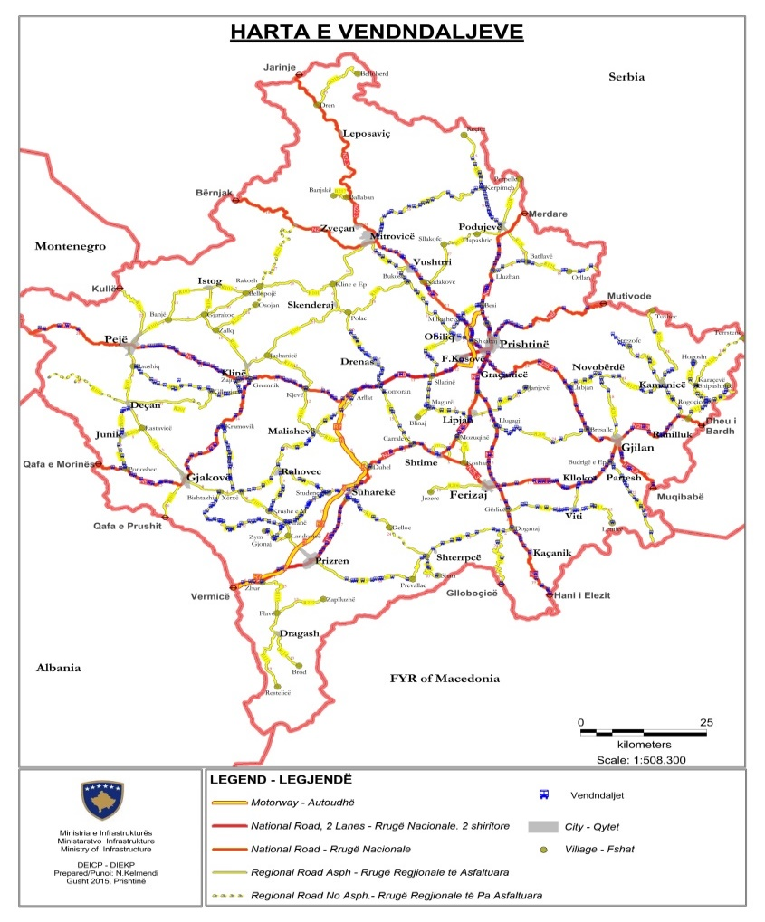
Total investment estimated:  - Preparatory activities (planning documentation, technical documentation, land acquisition etc.)  - Construction works  - Supervision | Total investment estimated: 27,500,000 EUR  Of which:  - Preparatory activities: 2,000,000 EUR  - Construction works: 23,500,000 EUR  - Project supervision: 2,000,000 EUR
Responsible or authorized person for contact: | Xhemë Veseli
Name – Position: | Director of the Road Transport Department
Email address - Telephone: | Xheme.Veseli@rks-gov.net

- PROJECT DESCRIPTION

Purpose of the infrastructure project | This project has a vital role in the development of transport in the Republic of Kosova. The goal of the project is to reduce travel time and delays, improve road surface conditions, which will result in vehicle operating cost savings, accident cost savings; saving the cost of travel time, and increasing road safety.  In 2015, a commission was formed for identifying and assigning bus stops on the national and regional roads of the Republic of Kosova. The Commission met with the aim of clearly defining the work methodology (since there was no data in MI regarding the bus stops); first it did a test in the region of Podujeva to see how identification/assignment can be done in accordance with the given task. From the test in the field, it has resulted that there are mostly bus stops on the national roads, but they need to be identified and in certain cases new bus stops will have to be assigned, since the situation on the ground has changed a lot in recent years. Such a situation has not been encountered in most of the regional roads and the need to assign stops on these roads has been presented.  In order to carry out the work in the most professional manner, the Commission has agreed to first draw up and analyse the maps containing the aerial photographs of 2012, where the concentration of the population, the location of schools and other public facilities are clearly shown. Then the Commission continued the work in the field where, by means of GPS, it made the identification/designation of the exact bus stops in the road segments. In addition to the coordinates of the stops, the Commission has agreed to collect other data such as: road relation, location of the stops, condition of the stop, whether or not there is a sign indicating the stop, whether the stop is necessary or not, and for each stop given the ID.  The construction of bus stops tends to reflect the level of usage, where stops at busy locations may have shelters, seating, and possibly electronic passenger information systems.  The shelter must have properties including strength, toughness, durability, aesthetics, compatibility with the surrounding environment, and sufficient lighting system. In the open spaces, shelters should be resistant against the sun, rain and snow, and environmental conditions (frost and melting).
Results of the infrastructure project | The implementation of the project will have a direct impact on the improvement and creation of facilities in the inter-urban road transport of travelers within Kosova and will contribute to the integration of Kosova in the transport system of the region and the whole of Europe.  This project will also affect the following:  - reduction of travel time;  - reduction of road infrastructure maintenance costs;  - better connection in the Western Balkans Region;  - cost efficiency in relation to environmental protection, accidents and the urban/inter-urban area near the existing road compared to competing roads.  The current and urgent need to move towards improving road/bus stop conditions is the Feasibility Study and updating the Detailed Design for such a project.  The result of the update of the feasibility study will be the creation of the spatial, environmental, social, financial and economic justification for the investment in the construction of bus stops on the national and regional roads of the Republic of Kosova.  On this basis, the investment decision will be made and the procedure for issuing the construction approval will be initiated. The technical design documents will also define the purpose, position, extent, cross section, capacity as well as the technical, technological and functional characteristics of this project.
General description | The main inter-urban transport network includes the 7 regions of the Republic of Kosova which connect the main cities and then connect with the neighboring and wider countries.  One of the main objectives stated in the Multimodal Transport Strategy 2023-2030 is the creation of connections with the European transport network and - in line with this - provide a priority passenger transport road network connecting transport gateways with areas of potential economic growth, which have been defined by the Government of Kosova as part of this priority road network.  The number of stops identified according to the above elaborations is 1,717, taking into account that approximately 200 stops were built in certain road segments with the state budget.  The proposed project is part of the Major National Roads connecting the regions and beyond. It has an obvious strategic dimension from the regional point of view, which is the reason to be confirmed as such a project in the comprehensive transport network defined by TEN-T.  This proposal is part of TEN-T, and therefore in the high priorities regarding the development of the transport network in Kosova.  The National Transport Model predicts a very high increase in traffic. This will give Kosova access to the main corridors in the Western Balkans, so the construction of this project will provide convenience and security for the citizens of the Republic of Kosova and also for the providers of transport services.  In addition to the regional importance of this project, this project serves many travelers for daily access to work, study, etc. With the construction of the respective stops, it is expected that the economic potential of this region will be strongly explored and promote the economic growth of all parts of Kosova.  The feasibility study and the construction of these bus stops had an impact on the improvement of inter-urban transport connections, but they have not yet been implemented through the construction of roads due to insufficient funds. To continue with the construction of these stops and to have access to IFI funds, the existing Feasibility Study and Detailed Design should be updated.

- ELIGIBILITY

Coherence with valid EU policies and strategies | It is in coherence with EU Road Safety Policy Framework 2021-2030. New policy framework is the adoption of the so-called "Safe System" approach, which aims at reframing road safety policy by focusing on the prevention of deaths and serious injuries in four core elements: safe vehicles, safe infrastructure (one of the measures is construction of overpasses), safe road use and better post-crash care.  The Instrument for Pre-Accession Assistance (IPA III) 2021-2027, states that IPA III will devote attention to transport safety and security, especially in road transport, and passengers’ rights in accordance with the EU requirements and targets to reduce road fatalities and serious injuries. Also, IPA III will support the construction of new transport infrastructure and the upgrading of existing infrastructure, with the objective of bringing the core transport network up to EU standards. It will also support intermodal connections and the gradual shift from individual road transport to public or shared mobility.
Contribution to valid national development objectives | The project is in line with the Stabilisation and Association Agreement (SAA), between Kosova and the European Union as stated in Article 113 of this agreement:  “Cooperation between the Parties shall focus on priority areas related to the EU acquis in the field of transport. Cooperation may notably aim at restructuring and modernizing Kosovo’s transport systems and improving related infrastructures (including regional links as identified by the South-East Europe Transport Observatory), improving the free movement of passengers and goods, achieving standards interoperable with and comparable to those prevailing in the EU and aligning transport legislation to that of the EU, should objective circumstances so permit. Cooperation shall aim to contribute to progressive mutual access to the EU and Kosovo transport markets and facilities as provided for in this Agreement, developing a transport system in Kosovo compatible, interoperable and ligned with the EU system, and improving environmental protection in the field of transport.”  EU Country Report for Kosovo 2023 Report states that “Kosovo should implement CONNECTA report recommendations to improve the quality of the road network and actions.”  This project is in accordance with the National Economic Reform Program 2024-2026: “Reform measure # 13: Further development and modernization of Transport”.  Program of the Government of the Republic of Kosova (2021 – 2025) states that it will pay special attention in the field of structures for road traffic safety.
Coherence with national Transport Sector Strategic framework | Multimodal Transport Strategy 2030 states that “this strategy aims to bring a sustainable and integrated transport system by strengthening different modes (road, rail and air), such as convenience, speed, cost, reliability, predictability, etc., and in combination, can offer more efficient transport solutions for people and goods which will help ease the pressure in our congested roads, and make the whole sector more environmentally friendly, safer, and cost-effective.

- STRATEGIC RELEVANCE

Explain the features of the project in terms of:
Improving inter-modality | The bus stops will increase the safety in the roads, and as a result will raise the potential for improving inter-modality.
Increasing international traffic (freight, persons) | Regional and national roads are the main connections that directly affect the creation of facilities for the safe pick-up and drop-off of travelers.
Being included in the latest Multi-annual plan (MAP) of SEETO | It is included in SEETO's latest Multi-Annual Plan (MAP).
Providing connection to TEN-T corridors | The project is located on the stretch of Pan-European Corridors X and VIII, so it directly contributes to the connection between the TEN-T corridors.
Its contribution to Improvement of safety conditions | Currently, the movement of the population through different countries has presented the need for the construction of new stops and the repair or elimination of those that are unnecessary. With the construction of these stops, the security conditions will improve significantly.
New, upgraded or rehabilitated infrastructure | This project includes the infrastructure of the new stops, the maintenance of the existing ones, also taking into account the construction of new roads where the stop has not been designated or recorded.
Meeting annual traffic demand growth | It will contribute to increase the road traffic volume.
Time reduction for journeys | The construction of this section will significantly reduce the travel time, increase the safety level, especially considering the traffic jams in the absence of a stop, the formation of columns, etc.
Its effect on the reduction of CO₂ and noise emissions | Yes, based on the previous/preliminary EISA done in 2006 by COWI.
Its contribution to overall economic growth | The project will create a significant economic growth potential, which is considered important in the Western Balkans.
Its integration with other projects | This project is a continuation of the road infrastructure projects in Kosova, but also the connection with neighboring countries and beyond.
The existence of alternatives | Yes, as an alternative is considered the construction of bus stops with islands and without islands, separated from the road strip, also, the shelters are different models, so we need options or models depending on the assessment of the needs in the field for the construction of these shelters.

Part Two

- MATURITY

Available studies and documents | Ready and approved | Being worked on | Not started yet
Conceptual idea | X
Pre-feasibility study |  |  | X
Conceptual design |  |  | X
Feasibility study + CBA |  |  | X
EIA study (if needed) |  |  | X
Valid spatial planning documents |  |  | X
Land property resolved |  |  | X
Preliminary design |  |  | X
Main design/detailed design |  |  | X
Tender documentation |  |  | X
Construction and other permits |  |  | X
Construction contract signed |  |  | X

- DETERMINATION OF SOURCE OF FUNDING

 | Yes | Justification | No
Does the project enhance connectivity? | X | The project will be developed mainly in the road segments that are part of the core and comprehensive network.
Does the project have cross-border impact or impact on other countries in the region? | X | Since the project will be developed mainly in the road segments that are part of the core and comprehensive network, it can be said that it has cross-border impact.
Can the project in any other way be earmarked as a regional project? | X | The project is located in the extension of the Pan-European Corridors X. It has an obvious strategic dimension from the regional point of view, which is actually the reason to be confirmed as such a project in the comprehensive transport network defined by local and international mechanisms.

- SPENDING SCHEDULE

 | 2015-2020 | 2021 | 2022 | 2023 | 2024 | 2025 | 2026 | 2027 | 2028 | 2029 | 2030
Costs (in mil. EUR) of which: |  |  |  |  | 10.5 | 8.5 | 8.5
Project preparation (TA) |  |  |  |  | 2
Investment |  |  |  |  | 8.5 | 8.5 | 8.5

- OTHER ASPECTS

Have IFIs or other donors already been consulted on the project? When? What was their judgement? | A donor consultation meeting took place on 10 May 2023, where IFIs and other donors were invited to participate in a general discussion on the projects in the Transport sector SPP prior to its validation and approval.
Existing EU or WBIF support (TA): amount, purpose | No.
Has the Ministry of Finance already been consulted on the project? Describe feedback. | No.
Does the project generate revenues from end users? | No.
Description of project team for implementation | Project management is carried out by the Project Implementation Unit. The works are supervised by contract managers. Contract managers are employed by MESPI - Department of Land Transport staff.

