Project Identification Form (PIF): Transport Sector
Part One

- GENERAL INFORMATION

Project title: | Construction of the new railway line Ferizaj (Kosova) – Gjilan (Kosova) – Border with Serbia - Bujanoc (Serbia), 59 km
Sector | Transport
Subsector* (see list on the last page) | Rail
Lead project Beneficiary/proponent: | Ministry of Environment, Spatial Planning and Infrastructure (MESPI); Ministry of Economy (ME)  Kosova Railways Infrastructure JSC – INFRAKOS
Institution that is the author of the project proposal | Kosova Railways Infrastructure JSC – INFRAKOS  MESPI
Location/Map
Total investment estimated:  - Preparatory activities (planning documentation, technical documentation, land acquisition etc.)  - Construction works  - Supervision | Total investment estimated: 188,215,000 EUR  Of which:  - Preparatory activities: 6,000,000 EUR  - Construction works: 172,815,000 EUR  - Supervision: 9,400,000 EUR
Responsible or authorized person for contact: | Naser Krasniqi
Name – Position: | CEO of Kosova Railways Infrastructure JSC INFRAKOS
Email address - Telephone: | naser.krasniqi@kosovorailway.com;  Tel: +383 38 550 550 ext.505

- PROJECT DESCRIPTION

Purpose of the infrastructure project | The overall objective of the project is to support transport infrastructure development as well as reform processes in the transport sector in Kosova and the region in line with the relevant EU Directives and Regulations. The project will enable better multimodality, better interconnections with other transport modes and environmentally friendly transport solutions which will combine transport modes by road and rail.  The specific objective of this project is to create a new railway line between Railway Station Ferizaj in Kosova and the Railway Station Bujanoc in Serbia, in order to connect Railway Route 10 and access of the South East Kosova economy with Corridor X.  Implementing this project, Kosova will develop good connection with regional railways and Pan-European corridors; intermodal and multi modal transport; it will increase number of people with improved access to services; and it will open railway market for domestic, regional and international train operators.
Results of the infrastructure project | The construction of this new line will link two cities of two neighbouring countries and will enable interoperable railway infrastructure which will support safe railway transport and railway market for domestic, regional and international train operators. The main stakeholders affected by this project are the state railway operator of Kosova (TRAINKOS) and all other train operators (local, regional and EU) who would like to use this infrastructure in the future.  General rehabilitation of Railway Route 10 is a precondition for development of the railway sector in Kosova, and implementation of this project will result in:  - Increased safety and speed conditions of this line;  - Interoperable railway infrastructure as a linkage between two neighbouring countries and the wider region;  - Better conditions for development of the passenger and freight transport;  - Increased economic growth and social development;  - Facilitated trade and economic links with neighbouring countries and EU member states;  - Improvement of transport capacities;  - Development of multimodal and intermodal transport in Kosova and beyond.
General description | The construction of this line will facilitate a shorter connection of Railway Route 10 with Railway Corridor X.  This project is with high importance for future socio-economic development of the region, especially for Kosova. Also, it contributes to regional cohesion and will assist in the development of seamless connections for passengers and freight in the Western Balkans.  The new railway line with length of approximately 59 km within Kosova will create a railway connection between Railway Station in Ferizaj in Kosova and Bujanoc in Serbia.  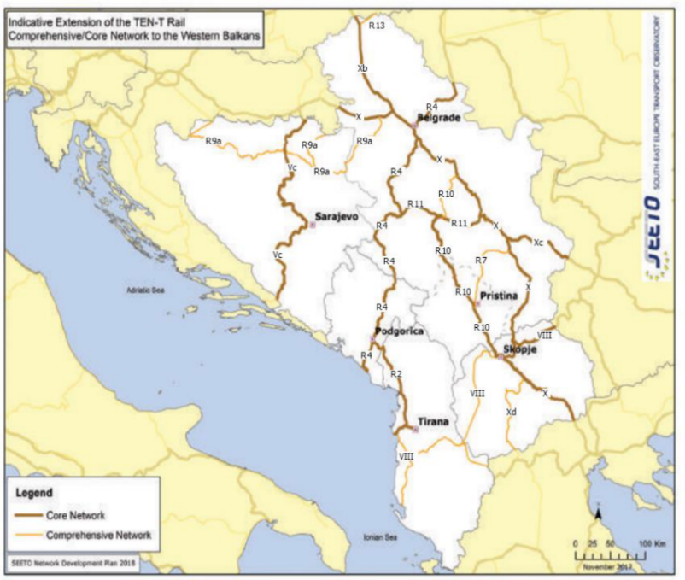

- ELIGIBILITY

Coherence with valid EU policies and strategies | The railway line has an obvious strategic dimension from a regional aspect for the development of the railway transport and is in line with EU policies and strategies.  An Economic and Investment Plan for the Western Balkans, Brussels, 6.10.2020, states that “fast and efficient transport links, both within the region and with the neighbouring EU Member States, and sustainable transport with further investment in rail and inland waterways are crucial. This promotes “further regional cooperation and integration, connecting capitals in the region and with the EU” and promotes “multimodal transport solutions and modal shift, and reducing transport related pollution.”  The European Green Deal, Brussels 11.12.2019, states that “a substantial part of the 75 per cent of inland freight carried today by road, needs to be shifted to rail and inland waterways.”  Sustainable and Smart Mobility Strategy, Brussels, 9.12.2020, states that “mobility in Europe should be based on an efficient and interconnected multimodal transport system, for both passengers and freight, enhanced by an affordable high-speed rail network, by abundant recharging and refuelling infrastructure for zero-emission vehicles and supply of renewable and low-carbon fuels, by cleaner and more active mobility in greener cities that contribute to the good health and wellbeing of their citizens.” The same strategy foresees that by 2030 high-speed rail traffic will double, and by 2050 rail freight traffic will double whereas high speed rail traffic will triple.  Strategy for Sustainable and Smart Mobility in the Western Balkans, July 2021, states: “Interventions are required to increase railway capacity and enable more competitive rail services.” Also, according to the strategy:  - By 2030, rail freight traffic to increase by 20 percent; this to double by 2050.  - By 2035, rail and waterborne-based intermodal transport to compete on equal footing with road-only transport in the Western Balkans.  One of the objectives of EBRD stated in Transport Sector Strategy (2019-2024), October 2019, is the “investment in rehabilitation and expansion of national, regional and sub-urban rail infrastructure and signalling, to improve access to markets and services, and create linkages to key transport networks and corridors, including TEN-T, WBCN, CAREC, TRACECA and BRI in the economies where the Bank invests.”  The integration of Kosova into regional rail transport networks will be facilitated via the Western Balkans Investment Framework (WBIF) and relevant regional programmes. Also, considered for investment from The European Bank for Reconstruction and Development (EBRD).
Contribution to valid national development objectives | The project is in line with the Stabilisation and Association Agreement (SAA), between Kosova and the European Union as stated in Article 113 of this agreement:  “Cooperation between the Parties shall focus on priority areas related to the EU acquis in the field of transport. Cooperation may notably aim at restructuring and modernising Kosovo’s transport systems and improving related infrastructures (including regional links as identified by the South-East Europe Transport Observatory), improving the free movement of passengers and goods, achieving standards interoperable with and comparable to those prevailing in the EU and aligning transport legislation to that of the EU, should objective circumstances so permit. Cooperation shall aim to contribute to progressive mutual access to the EU and Kosovo transport markets and facilities as provided for in this Agreement, developing a transport system in Kosovo compatible, interoperable and linked with the EU system, and improving environmental protection in the field of transport.”  In the Program of the Government of the Republic of Kosova 2021 – 2025, the government stresses its commitment to create an integrated system for road, rail and air transport, for the purpose of economic development, and to modernise and develop the railway infrastructure, in order to provide more sustainable services.  EU Country Report for Kosovo states: “Kosovo should implement the pending connectivity projects and strengthen institutional and administrative capacities for the implementation of strategic infrastructure projects.”  Economic Reform Programme 2024-2026 foresees that further connectivity with neighboring countries would strengthen the country’s integration into the regional market.  National Programme for European Integration 2023-2027 promotes modern and better regional railway infrastructure, in order to connect to the Pan-European corridors.  Medium Term Expenditure Framework 2022-2024, April 2021 states that “Infrastructure will continue with investments in road and railway infrastructure of national and international importance, will also work to build infrastructure of national importance that connects the regions of Kosovo and those that ensure economic growth.”  The Government intends through development banks to finance the rehabilitation of this railway line.
Coherence with national Transport Sector Strategic framework | Multimodal Transport Strategy 2030 aims to bring a sustainable and integrated transport system by strengthening different modes (road, rail and air), such as convenience, speed, cost, reliability, predictability, etc., and in combination, can offer more efficient transport solutions for people and goods which will help ease the pressure in our congested roads, and make the whole sector more environmentally friendly, safer, and cost-effective. Also, it is stated that “EU’s transport policy is naturally aligned with the global trends presented above. It can be emphasized though that there is a special attention being made towards the uptake of zero-emission vehicles, development of rail transport and the reinforcement of a single market which is based on the user-pays principle.” Also states that “Besides the low quality of infrastructure, Kosova’s railway also lacks ERTMS. This is a key component of making railway traffic competitive and safe and thus all modernization projects should include deployment of ERTMS. As most accidents on railway happen on road-rail crossing deploying ERTMS will also help to reduce the number of fatalities related to railway transport.”

- STRATEGIC RELEVANCE

Explain the features of the project in terms of:
Improving inter-modality | By implementing the construction of this line, Kosova will improve and develop in highest level intermodal transport on a local, regional and international level. This will facilitate “door to door” transport using railway and road vehicles.
Increasing international traffic (freight, persons) | Yes.
Being included in the latest Multi-annual plan (MAP) of SEETO | No, this project is not included in the SEETO MAP 2018.
Providing connection to TEN-T corridors | The line will connect to Railway Route 10 and TEN-T Corridor X.
Its contribution to improvement of safety conditions | Rehabilitation of this line will be done in accordance with the contemporary railway safety standards. Having in mind the current condition of the respective railway line, this project will have significantly improve safety conditions.
New, upgraded or rehabilitated infrastructure | Rehabilitated infrastructure.
Meeting annual traffic demand growth | The project meets requested criteria for transport growth.
Time reduction for journeys | Construction of this line will provide shorter and safer trip between Kosova and Serbia and between the markets for more than two hours.
Its effect on the reduction of CO₂ and noise emissions | Realizing this project will lead to the predominant part of road freight transport being shifted to railways which would have significant impact in respect to the reduction of CO₂ and noise emission.  This project has sustainability in relation to environmental aspects, because it is known that trains have very low emission of C02 comparing with road vehicles. In this way we will have clean environmental ambient along the railway line. This project will consider environmental implications so that any negative impacts on the environment will be either avoided or mitigated during the life of the project.
Its contribution to overall economic growth | Improvement of transport infrastructure across the Western Balkans is a key element to ensure connectivity, sustainable economic growth and cohesion among the Regional Parties and European Union.  The project will facilitate significant inter-regional economic growth and contribute to regional cohesion and assist in the development of seamless connections for passengers and freight in the Western Balkans, primarily by connecting Kosovo and the neighbouring countries.  Enhancing connectivity within the Western Balkans represents a strategic interest for both sides. Increasing transport connections will allow for increased competitiveness, economic growth and security of supply, and is at the same time an important prerequisite for economic integration within the Western Balkans.  The Western Balkans are surrounded geographically by EU Member States and it is a political priority to connect infrastructure also between the EU and the Western Balkans and to accelerate the development of interconnected trans-European networks in transport.
Its integration with other projects | This project is closely related to the investments on Rail route 10 in Kosova and investments in railway Corridor X in Serbia.
The existence of alternatives | Alternative options will be analysed in the course of preparation of technical documentation for the construction of the new railway connection.

Part Two

- MATURITY

Available studies and documents | Ready and approved | Being worked on | Not started yet
Conceptual idea |  |  | X
Pre-feasibility study |  |  | X
Conceptual design |  |  | X
Feasibility study + CBA |  |  | X
EIA study (if needed) |  |  | X
Valid spatial planning documents |  |  | X
Land property resolved |  |  | X
Preliminary design |  |  | X
Main design/detailed design |  |  | X
Tender documentation |  |  | X
Construction and other permits |  |  | X
Construction contract signed |  |  | X

- DETERMINATION OF SOURCE OF FUNDING

 | Yes | Justification | No
Does the project enhance connectivity? | X | The realization of the project will have direct impact on the improvement of the railway connection within Kosova, with regional countries and Integrated EU Network.
Does the project have cross-border impact or impact on other countries in the region? | X | This railway line has cross-border impact with Serbia and also will have impact on other neighbouring countries.
Can the project in any other way be earmarked as a regional project? | X | Taking into consideration the regional development, the link with the Bujanoc and access to Corridor X, this project can be considered as regional project, too.

- SPENDING SCHEDULE

 | 2015-2020 | 2021 | 2022 | 2023 | 2024 | 2025 | 2026 | 2027 | 2028 | 2029 | 2030
Costs (in million EUR) of which: |  |  |  |  |  |  |  |  | 6.00 | 91.60 | 90.615
Project preparation (TA) |  |  |  |  |  |  |  |  | 6.00 | 4.7 | 4.7
Investment |  |  |  |  |  |  |  |  |  | 86.90 | 85.915

- OTHER ASPECTS

Have IFIs or other donors already been consulted on the project? When? What was their judgement? | A donor consultation meeting took place on 10 May 2023, where IFIs and other donors were invited to participate in a general discussion on the projects in the Transport sector SPP prior to its validation and approval.
Existing EU or WBIF support (TA): amount, purpose | No.
Has the Ministry of Finance already been consulted on the project? Describe feedback. | The Ministry of Finance, Labour and Transfers is informed concerning this project and it will support this project.
Does the project generate revenues from end users? | This project is as a precondition for future developments and will generate revenues from train operators.
Description of project team for implementation | INFRAKOS will establish PIU for implementation of this project.

